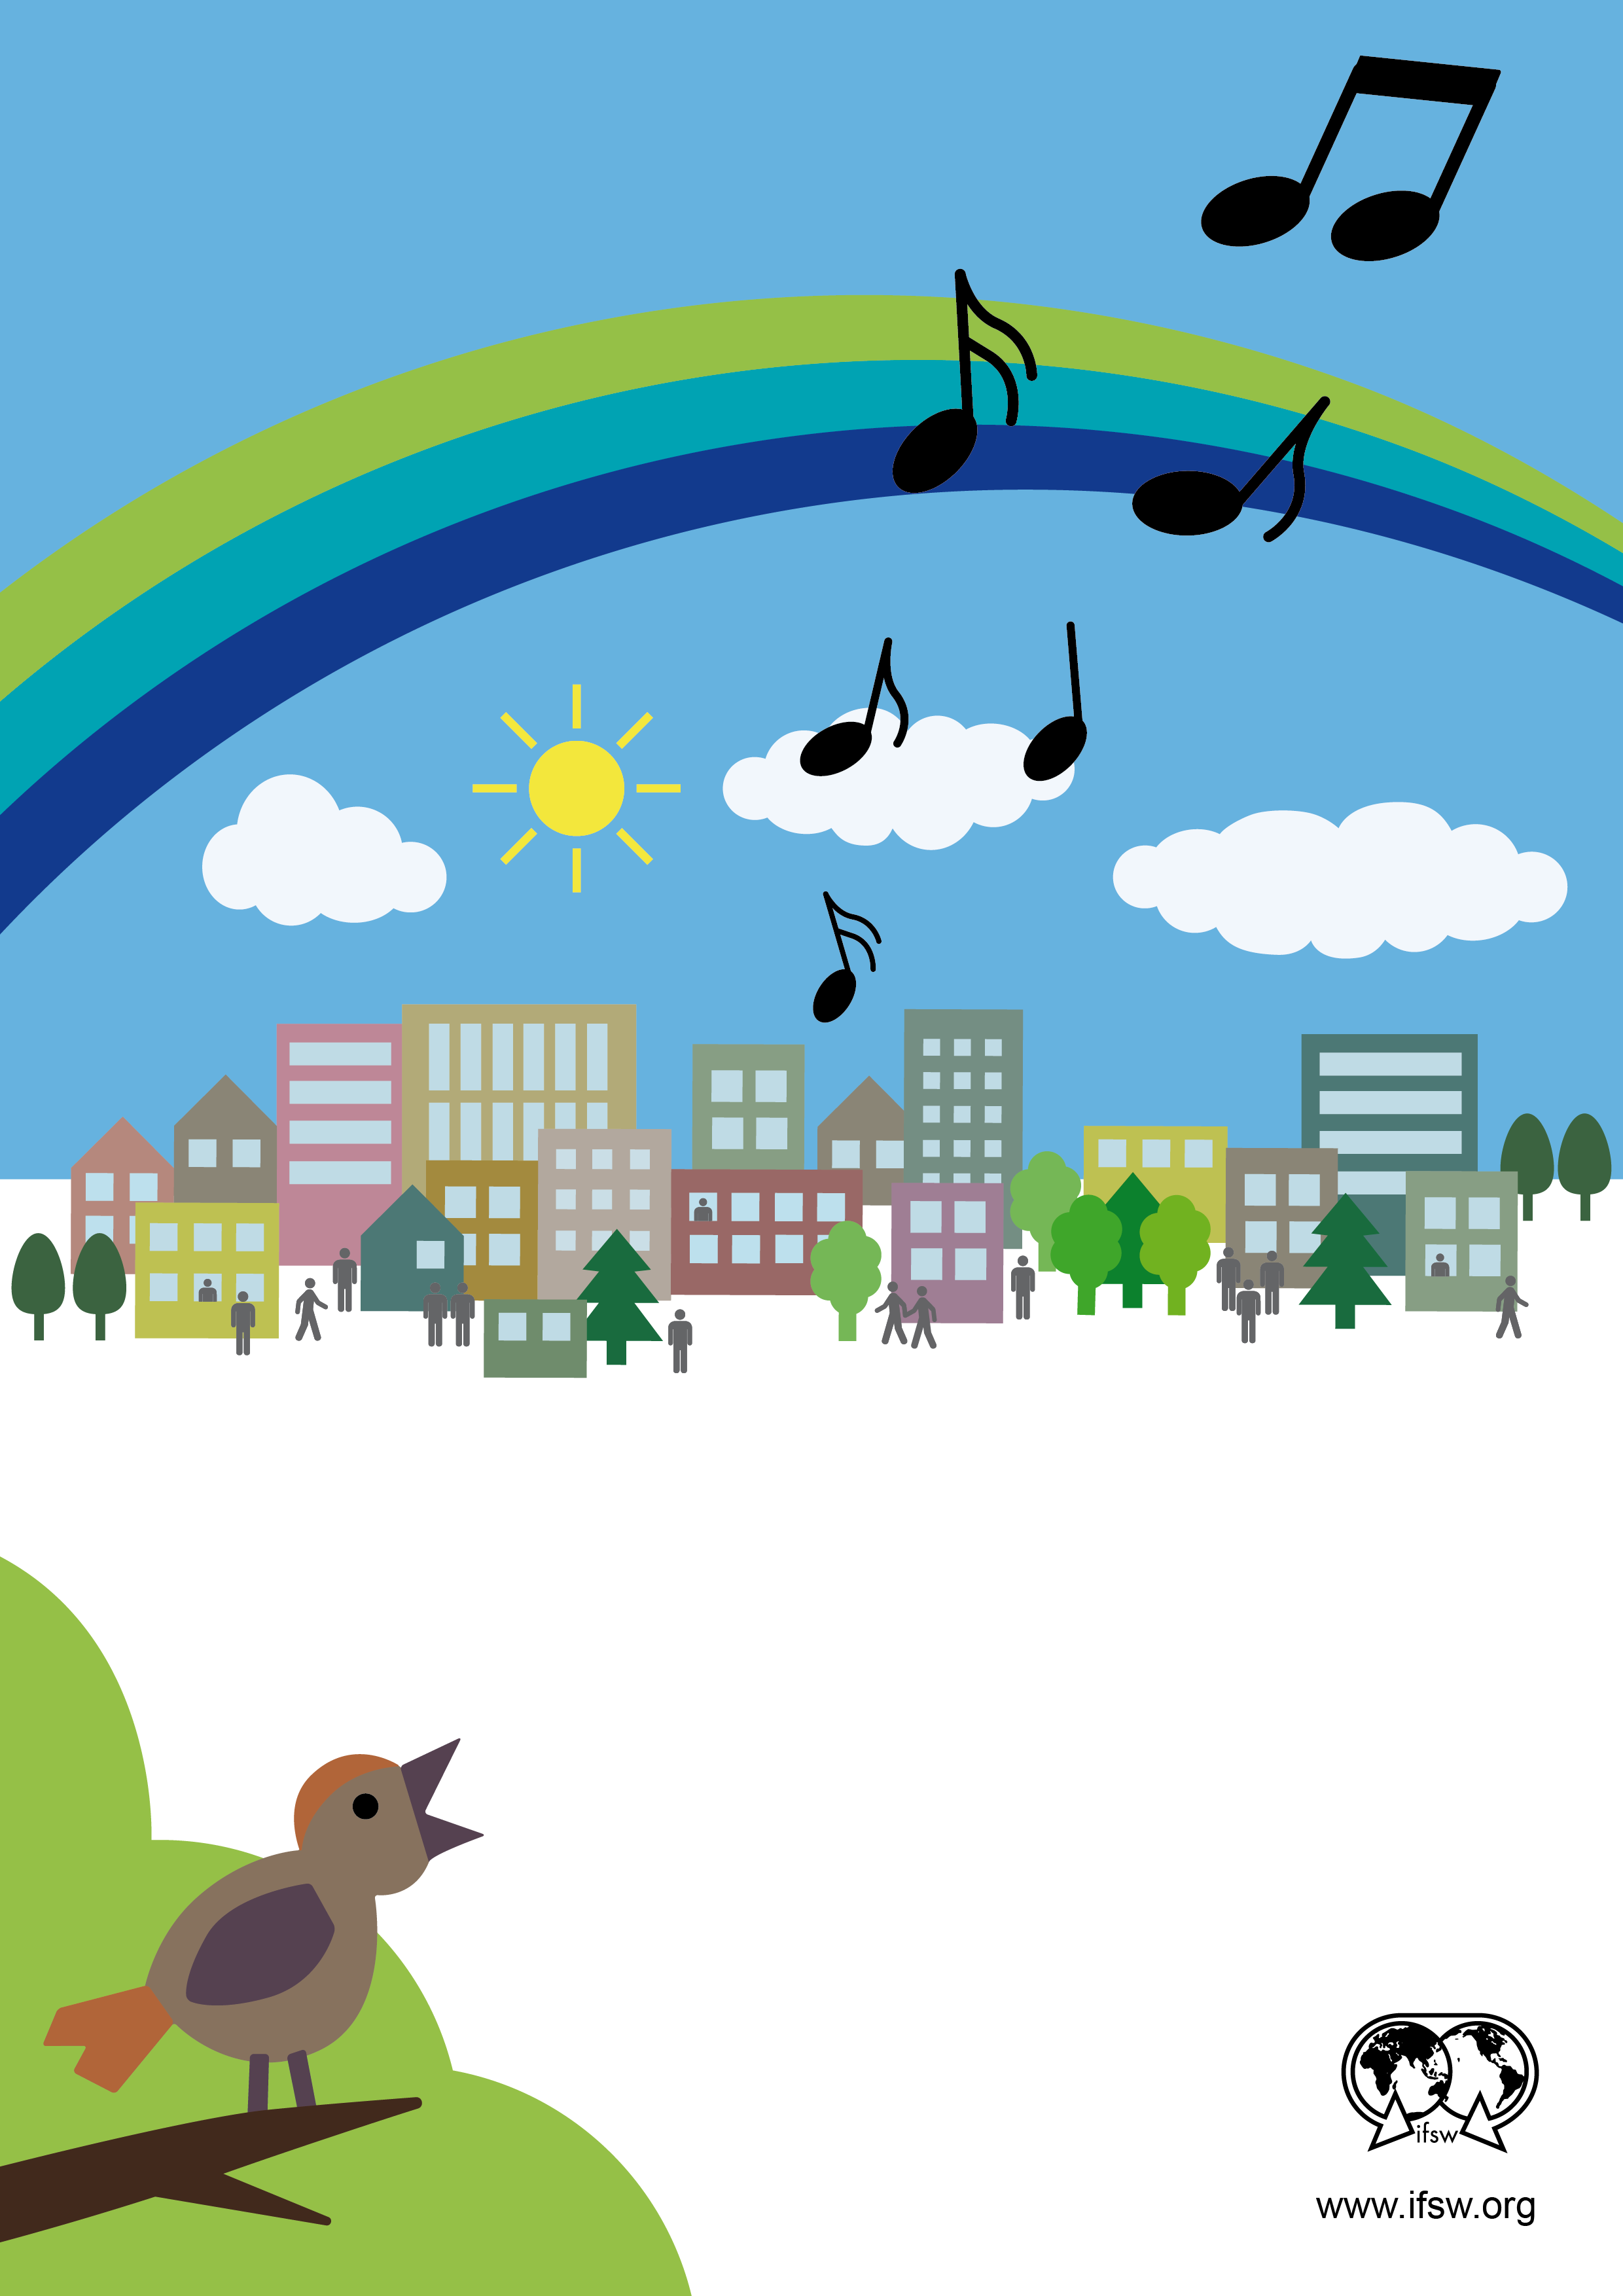

Societies thrive when the

dignity and rights of all

peoples are respected

**SOCIAL WORKERS TOWARDS**

**AN UNDIVIDED HUMANITY.**

**WORLD SOCIAL WORK DAY**

**MARCH 15, 2016**