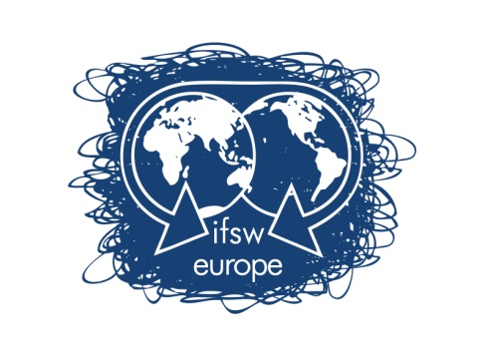

International Federation of Social Workers – European Region

Application for funding for the Delegates Meeting, Zagreb, 13th - 15th May 2016

Applicant’s Name:

Applicant’s address:

E-mail address:

Phone Number:

Office held in member organisation:

How will attendance at the meeting help you and your organisation?

Please give details of any other funding applied for:

Please give details of the travel and visa costs:

Note that the application form must be accompanied by a letter from the applicant’s organisation confirming their support for the applicant’s attendance at the meeting, including information on the applicant’s position in the member organisation

Applications should be returned by the 17th of April 2016 to:

Brian Auslander
Treasurer of IFSW Europe e.V.
Email: bauslander@gmail.com

Contact:
Brian Auslander
Treasurer of IFSW Europe e.V.
31 Derech Hachoresh
Jerusalem 97278, Israel
Phone: +972 54 4453884

