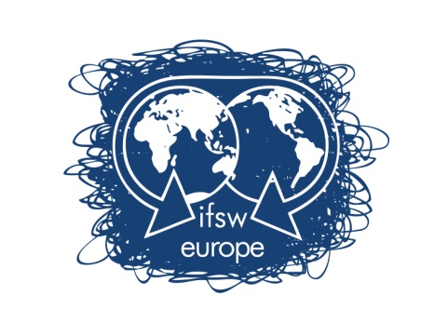

International Federation of Social Workers - European Region

Funding to attend the Delegates Meeting in Zagreb, Croatia 13th – 15th of May 2016

A small sum of money is allocated each year in the IFSW Europe e.V. budget to enable social work organisations that don’t have the financial capacity to attend the Delegates Meeting held by IFSW Europe e.V. annually.

The criteria for applying for funding to attend the Delegates Meeting in Zagreb, 13th - 15th of May 2016 are:

- Applications should be made to the treasurer of IFSW Europe e.V. by the 17th of April 2016.
- Applications should state why the applicant wishes to attend the Delegate meeting and what he/she hopes to gain from attendance at the meeting.
- Applications must be accompanied by a letter from the member organisation confirming their support for the applicant’s attendance, including information on applicant’s position in the member organisation.
- Applications must explain the financial situation of the member organisation.

In allocating the funding consideration will be given to the following:

- Whether the organisation of which the applicant is a member has paid their annual fees for 2015 and 2016 to IFSW Europe e.V.
- Whether the applicant or any other member from the organisation has received funding previously.
- Only a part of costs for attendance at the meeting will be met as IFSW Europe e.V. aims to support a large number of applicants. Applicants are likely therefore to need to seek other funding, too.
IFSW Europe will only support one member from each organisation on the travel (airfare), visa and accommodation during the days of the Delegates meeting at the hotel suggested by the host organisation or in the same amount of the cost of those rooms. IFSW Europe will not pay any other extra expense (meals, etc)
- When all the applicants have been received by the treasurer, he will examine them and make a report and recommendation to the Executive Committee.
- Applicants will be informed not later than the 24th of April of the decision.

On behalf of the IFSW Europe e.V. Executive Committee

Brian Auslander
Treasurer of IFSW Europe e.V.

Contact:
Brian Auslander
Treasurer of IFSW Europe e.V.
31 Derech Hachoresh
Jerusalem 97278, Israel
Phone: +972 54 4453884

Email: bauslander@gmail.com

