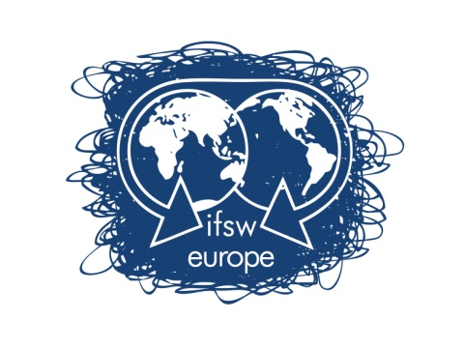

International Federation of Social Workers – European Region

Delegates Meeting for IFSW Europe e.V.

Zagreb, Croatia, 13-15 May 2016

Expression of Interest in Appointments of External and Internal Representatives of IFSW Europe e.V.

Name: Click here to enter text.
Member Organisation: Click here to enter text.
E-mail address: Click here to enter text.

Please indicate the position(s) you are interested and the capacity in which you would wish to serve:
Please X as appropriate

Position | Representative | Support Member
Council of Europe | ☐ | ☐
Global Human Rights Commission | ☐ | ☐
Permanent Committee on Ethics | ☐ | ☐
European Social Platform | ☐ | ☐
European Anti-Poverty Network | ☐ | ☐
Fundamental Rights Platform | ☐ | ☐
European Organisation of Rare Diseases | ☐ | ☐
H2020 Project(s) | ☐ | ☐

Please give a brief account of knowledge and experience you have relevant to the position(s) below:

Current Employment Status: Click here to enter text.
Length of Time Position held: Click here to enter text.
Do you have the support of your employer to attend meetings? Click here to enter text.
Will you be allowed time off work to attend meetings? Click here to enter text.
Do you have the support of your Membership Organisation? Click here to enter text.
How much of your own time are you able to devote to the position(s)? Click here to enter text.

Please indicate the level of your skills in both spoken and written English and in any other languages using the codes below:
Fluent (1); Very good (2); Good (3); Fairly good (4)

Language | Spoken | Written
Click here to enter text. | Click here to enter text. | Click here to enter text.
Click here to enter text. | Click here to enter text. | Click here to enter text.
Click here to enter text. | Click here to enter text. | Click here to enter text.
Click here to enter text. | Click here to enter text. | Click here to enter text.

Please indicate the level of your IT skills using the codes below:
Excellent (1); Very good (2); Good (3); Fairly good (4)

E-Mail | Click here to enter text.
Word | Click here to enter text.
Excel | Click here to enter text.
Power point | Click here to enter text.

The completed form shall preferably be sent by e-mail by 25th April 2016 to Cristina Martins, IFSW European President: martinscristina25@hotmail.com and certainly presented to her at the Delegates Meeting in Zagreb no later than 4pm on the 14th May 2016.

