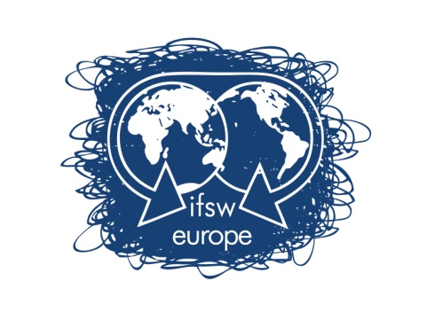

Call for expressions of interest to host the
IFSW European Conference 2019
IFSW Europe e.V., International Federation of Social Workers European Region

IFSW Europe e.V. is calling for expressions of interest from member organisations willing to host the 2019 IFSW European Conference.
The aim of the Conference is to bring together the fields of social work intervention and professional practice, policy making and research and to provide an opportunity for social workers to share their experiences, common problems and focus on strategies at European level.

The Executive committee of IFSW Europe e.V. is keen to make a decision about this as earlier as possible to enable the event to be promoted at the IFSW European Conference 2017 in Reykjavik, Iceland.
Applicant organisations must be in membership of IFSW Europe e.V..
Closing Date for Applications: 12th June 2016
Expressions of interest are to be submitted to the president of IFSW Europe e.V.,
Cristina Martins
Mail-address: martinscristina25@hotmail.com
Application Material
The submission of the expression of interest must contain a written agreement of the national organisation.
Expressions of interest must address the items identified in Appendix 1.
Applicant organisation(s) must also complete a checklist form in Appendix 2.
Process
IFSW Europe e.V. calls for expressions of interest to their members.
Expressions of interest must be submitted before 12th June 2016. Their receipt will be acknowledged within one working week.
This is a very important decision therefore at the Delegates Meting 2016 in Zagreb, Croatia, the delegates will be asked to approve a proposal from the Executive committee of IFSW Europe e.V. that a final decision is made on this occasion, by postal ballot.
The IFSW Europe e.V. Executive committee will review the submissions by 13 June 2016, distributing the applications received to all member organisations as soon as possible after this date.
IFSW Europe e.V. Executive Committee will make recommendations to prioritise the expressions of interest received taking into account the following;
- The financial viability and organisational capacity of the host organisation(s).
- The level of anticipated local participation and support for the IFSW European Conference.
- An indicative budget which demonstrates an understanding of the elements of conference planning
- Indicative themes
- Proposed venue, including ways of access to the venue from all parts of Europe
- Proposals for fieldwork visits
- Proposals for social events
- Capacity for translation

APPENDIX 1
APPLICATION TO HOST THE IFSW EUROPEAN CONFERENCE 2015
Proposed Host Country………………..………………..………………..…………
Name(s) of national member organisation(s):
IFSW Member(s) ………………..………………..………………..………
Please provide a description of proposals under each of the following headings
- Proposed Venue
  - City
  - Airport and other travel options, including access availability from all parts of Europe
  - Conference location
  - Capacity
  - Facilities
- Interpretation facilities
- Social activities
- Fieldwork visits
- Accommodation capacity
  - Range of options including home stay, budget, medium and upwards
- Local administrative support, including the national hosts’ local representation
Proposed Themes
Please describe any proposed theme and note that this is indicative only at this stage
Indicative Budget
The indicative budget should contain the following details
- Estimates set at various participation levels, e.g. 400, 700, 1000 participants.
- Any costs known at the time of submission e.g. venue costs, standard rates for translation and interpretation, travel costs for keynotes, etc.
- An indicative budget, which covers, all anticipated expenditures and sources of income, including levels of participants fee and costs of accommodation.

Representation
The conference organisers, called ‘Hosting Committee’ should ensure that all nationals of Europe will have easy access to the host country, including information about any visa-regulations.
Organisational Roles
Please provide a statement of respective roles of local member organisations. E.g. is the organisation accepting liability for the conference or is the liability to be shared and how?
Please describe the proposed local management process. At this stage a broad outline of the committee structure and numbers of representatives from each organisation is sufficient. Principles governing the establishment of the planning committees require equal representation from participating organisations and the appointment of co-chairs.
The Hosting Committee is not expected to be paid by the conference fees, and their expenses should not be part of the budget.
Professional Conference Organisers (PCO)
Please indicate whether you intent to make use of a Professional Conference Organiser.
Please ensure that you do not sign any contract with a Professional Conference Organiser without prior discussion and approval from IFSW Europe e.V.
Declaration
The Executive Boards of ………………….. (INSERT Organisational Name(s)) have approved this submission to host the 2019 IFSW European Conference.
IFSW Europe e.V. and the hosting organization(s) will accept mutual financial liability for the conference and equally share any surplus or loss that may occur.

Signed ………………………………… Signed ……………………………………
President President
For ………………………………………For ……………………………………….
Date ………………….. Date…………………..
APPENDIX 2
IFSW EUROPEAN CONFERENCE 2019 BID CHECKLIST
Organisation(s) proposing to host:………………..……………..………………
TASK Y/N COMMENTS
Our Board supports the bid
Our Board is aware of implications
We have approached other Organisation/s
We have discussed joint bid
We have the infrastructure to host
We are members of IFSW Europe e.V.
We have discussed with IFSW Europe e.V. members
We have sought local/government support
We have looked at suitable sites
We have considered using a Conference Organiser
We have developed agreement with other NGOs
We have completed bid form

