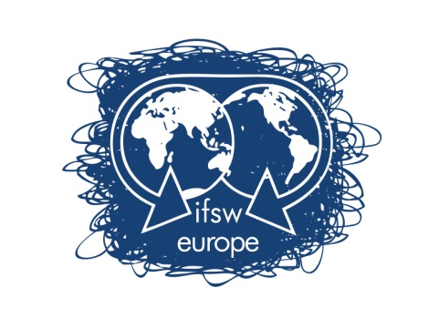 | FUNDING RULES FOR  DELEGATES MEETING BUCHAREST  18TH – 19TH – 20TH May 2018

IFSW Europe e.V. is glad to inform on the process to apply for financial support to attend IFSW Europe Delegates Meeting 2018, which will be held in Bucharest on May 18th – 20th.
Any delegate who wants to apply for economic support must:
- Fill in the application form
- Send it to IFSW Europe Treasurer, (bauslander@gmail.com) before April 2sd, 2018
- Applications must be accompanied by a letter from the IFSW Europe member organisation:
- Confirming their support for the applicant’s attendance at the meeting,
- Informing on the applicant’s position in the member organisation
- Explaining the financial situation of the organisation

In allocating the funding consideration will be given to the following:
- Whether the IFSW Europe organization has paid their annual fees for 2017 and 2018 to IFSW Europe e.V.
- Whether the applicant or any other member from the organisation has received funding previously.
- IFSW Europe will only support one member from each organisation
- IFSW Europe will provide, full or partial economic support until a maximum of 750€, including the following expenses:
- Travel (airfare),
- Visa
- Accommodation during the days of the Delegates meeting at the hotel suggested by the host organisation or in the same amount of the cost of those rooms. IFSW Europe will not pay any other extra expense (meals, etc)

In order to allow early bookings of flights and accommodations, applications must be received by IFSW Europe e.V. Treasurer, Brian Auslander, (bauslander@gmail.com) before April 2sd at 12h00 GMT. Please send all documents by email.
The decisions of IFSW Europe executive will be communicated no later than 2sd April
If you have any doubt, please do not hesitate to contact me,
On behalf of the IFSW Europe e.V. Executive Committee

Brian Auslander
Treasurer of IFSW Europe e.V.
Email: bauslander@gmail.com
Phone: +972 54 4453884

APPLICATION FORM FOR FUNDING SUPPORT

DELEGATES MEETING BUCHAREST
18TH – 19TH – 20TH May 2018

Applications must be received by IFSW Europe e.V. Treasurer, (bauslander@gmail.com) before April 2sd at 12h00 GMT.
Applicant’s Name:_________________________________________________________________

- Applicant’s address: ______________________________________________________________
_____________________________________________________________________________________

- E-mail address: __________________________________________________________________

- Phone Number: _______________________________________

- IFSW member organisation: _________________________________________________________

- Could you explain why do you want to attend the Delegates Meetings? (max 150 words)
_______________________________________________________________________________________

_______________________________________________________________________________________

- Could you explain how your participation on the DM will impact on your organization? (max 150 words)

_____________________________________________________________________________________

_____________________________________________________________________________________

- Please give details of any other funding that applied for:

_____________________________________________________________________________________

_____________________________________________________________________________________

- Please give details of the funds you apply for in euros:

- Travel: ___________________________________________________________
- Visa costs: _______________________________________________________
- Others: ___________________________________________________________

Note that the application form must be accompanied by a letter from the applicant’s organisation confirming their support for the applicant’s attendance at the meeting, including information on the applicant’s position in the member organisation

Brian Auslander
Treasurer of IFSW Europe e.V.
Email: bauslander@gmail.com
Phone: +972 54 4453884

