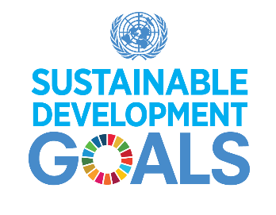
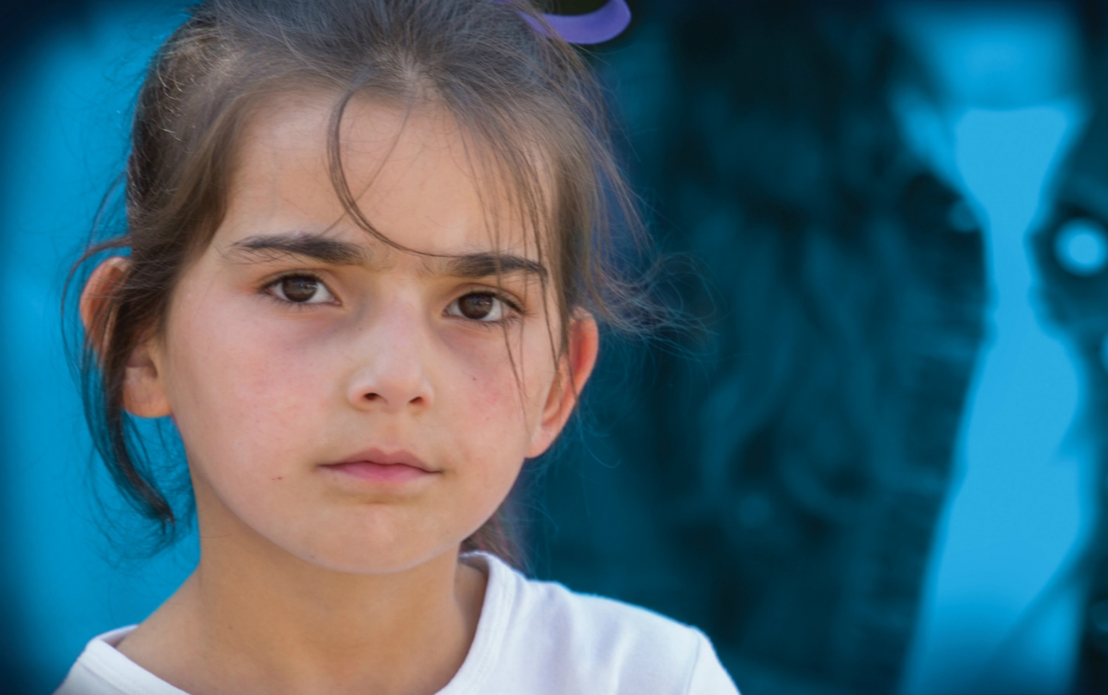

ARMENIA

CONCEPT NOTE

Role of social protection in the sustainable development agenda - Leaving no one behind in Armenia
The year 2018 marks 100 years of the Ministry of Labour and Social Affairs of the Republic of Armenia, as well as 25 years since the establishment of social services in the country. Armenia also committed itself to the global agenda of sustainable development and to the challenging goals of poverty reduction, which are intertwined with economic development, social protection, education, health and other sectors of the country.
Acknowledging the key role of the social protection sector in sustainable development, particularly the notion of leaving no one behind, it is of outmost importance to unwind the key elements of social protection that contribute to human capital development and represent an investment in today’s and future generations.
The high-level conference will be organized in partnership between United Nations Children’s Fund (UNICEF), World Bank, the Ministry of Labour and Social Affairs of the Republic of Armenia and the Armenian Association of Social Workers.
Objectives
The primary objective of the conference is to make a clear case for the important role that social protection can and should play in sustainable development of Armenia, particularly in reducing the effects of poverty on families and children, building human capital and leaving no one behind. More specifically, social protection of families and children within the principle of leaving no one behind and overall investment in human capital development can best mitigate the impact of poverty on current and future generations.
The specific objectives include:
- Revamp the role of social protection in the context of poverty reduction, sustainable development and development of human capital, and as a necessary prerequisite for achieving outcomes in other areas, such as employment, health, education, nutrition, life free from violence, gender equality, etc.
- Reshape social protection policies through a life-cycle approach that lifts families and girls and boys out of poverty and protects them from its impacts (social protection as an investment in human capital rather than an expense),
- Rethink the mix of social protection interventions, including social safety nets, social work and support services in achieving social justice and developing human capital, with linkages and in parallel to labour market activation,
- Advance deliberate policy decisions that will ensure that Armenia’s economic growth benefits all of its citizens, including making sure that vulnerable population categories are fully considered in poverty reduction plans.
The conference will seek to stimulate, motivate, promote and advocate for an increased role of social protection in development and poverty reduction by all actors across a range of levels and in a coherent and coordinated manner, based on international learning, networking and knowledge-sharing.

Key themes
- The role of social protection in sustainable development and poverty reduction
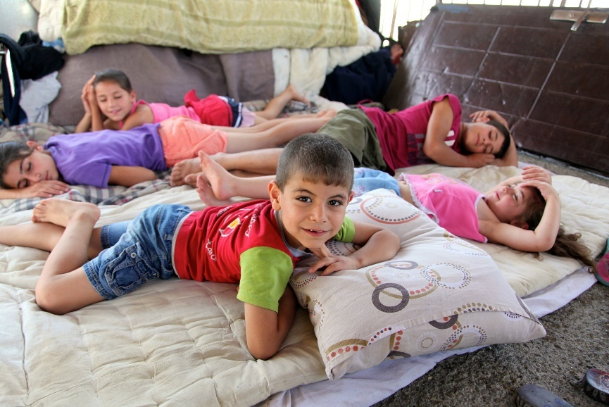
- Poverty profile of Armenia – can we get there by 2030?
- What does leaving no one behind mean globally, and for Armenia?
- Integrating and implementing social protection in the sustainable development agenda: opportunities, challenges, lessons learnt.
- Financing of social sectors for sustainable development, including health, education and social protection (affordability of social protection systems within domestic financing).
- Social Safety Nets as Empowerment Tools throughout the Lifecycle
Social safety net (SSN) programs include cash and in-kind transfers targeted to poor and vulnerable households, with the goal of protecting families from the impact of economic shocks, natural disasters, and other crises.
- SSN design – What do they achieve? What are the key considerations for effectiveness and efficiency?
- SSNs through a person’s lifecycle and in achieving outcomes in the areas of disability, early years, health, education, nutrition.
- Social protection floors and social schemes promoting substantial coverage of the poor and the vulnerable.
- Accelerating global actions towards decent work through active labour market policies: activation of social safety nets for beneficiaries, with special focus on youth (activation, graduation).
- Development of better gender-sensitive policies such as flexible forms of employment, paid paternity leaves, child care services and promotion of shared responsibility within the family;
- Preventing and reducing vulnerability to conflict, natural disasters and economic downturns that send poor households into a downward spiral (shock-responsive social protection systems, humanitarian cash transfers in emergencies).
- Mixing Social Protection Measures for Accelerated Progress towards the SDGs: Integrated systems
Social protection acknowledges the need to address social and economic vulnerabilities to poverty and exclusion through a broad range of social protection measures, including social transfers, access to services, social and family support, as well as legislative reform. A more holistic and sustainable way of addressing human needs is promoted through tackling poverty, education, health, economy and employment in an integrated manner, which are all human development concerns.
- Opportunities, challenges and the role of social workers in the SDG era that bring an interconnected understanding of human needs and concerns that are economic, social and environmental (assessment of social needs and social effectiveness).
- Engagement of social workers in the development of human capital: accountability, motivation, leadership.
- Humanization and professionalization of social services.
- Social accountability – concerted effort of public-private-non-profit partnerships (social contracting as a form of collaboration between the State and CSOs);
- Integration and decentralization of services – localization of the SDGs? Supporting effective governance that ensures all service-users have a voice, particularly those left behind and most vulnerable. Beneficiary involvement in the design and implementation of social protection measures (voicing citizens’ demands);
- Curbing inequalities and exclusion that leave segments of society stuck in poverty: scaling up of social support and care service provision for the achievement of inter-linked SDG targets, by increasing access and improving the quality of social services such as healthcare, education, care for children, persons with disabilities, victims and witnesses of violence.
- Applying innovative IT solutions in social service delivery, monitoring and evaluation (sustainable and ethical use of technology in human services).
Conference participants
The conference participants will be mainly from Armenia, with participation of international experts. The conference will also be open for participation to other country representatives (governmental and non-governmental).
- High-level government officials and policy makers (Government, National Assembly, Ministries, sub-national authorities, etc.)
- NGOs and community-based organisations
- Social workers and other social service providers
- International organizations
- Private sector representatives, including diaspora organizations
- Adolescents and youth
- Academia
- Media
- Others interested in advancing social protection and reducing effects of poverty in Armenia
Tentative agenda and logistics
- Dates: October 31 – November 2, 2018 (2.5 days)
- City: Yerevan, Armenia
- Venue: tbc
Wednesday, 31 October 2018
9:00 – 9:30 Registration of participants
9:30 – 10:15 Opening remarks by high-level officials / intervention by adolescent girls and boys
10:15 – 11:00 Keynote speeches – setting the scene
11:00 – 11:30 Coffee break/media statements
11:30 – 13:00 Plenary session
13:00 – 14:00 Lunch / opening of the exhibition of social services
14:00 – 15:30 Plenary session
15:30 – 16:00 Coffee break
16:00 – 17:30 Thematic workshops/ sessions
17:30 – 18:00 Plenary session/ wrap-up of the day
18:00 Official reception
Thursday, 1 November 2018
9:15 – 11:00 Plenary session
11:00 – 11:30 Coffee break
11:30 – 13:00 Thematic workshops/ sessions
13:00 – 14:00 Lunch
14:00 – 17:30 Field visits/workshops on the spot
Friday, 2 November 2018
9:15 – 11:00 Plenary session
11:00 – 11:30 Coffee break
11:30 – 13:00 Thematic workshops/ sessions
13:00 – 14:00 Lunch
14:00 – 15:00 Plenary session – call to action document
15:00 – 15:30 Conference closure and next steps

The conference will be implemented through plenary sessions, thematic workshops and field visits, seeking also to incorporate novel formats that allow a dynamic and participatory exchange of ideas, including utilization of technology and participation of adolescents.
An exhibition of social services will be a key element of the conference in order to share best practices and determine how service providers can contribute to the reform process and have a voice in the development and practical work after the reforms have been implemented. The interested organizations would need to apply for participation by 30 September 2018.
Keynote speakers and experts will be encouraged to submit abstracts of their presentations by 30 September 2018 for review.
A rapporteur will accompany the entire conference and will elaborate a report of the seminar with the aim of advancing in the agreements and learning produced in the event.
A “call to action” document will be prepared as a result of the conference and as a roadmap for future work in advancing social protection systems in Armenia that contribute to the agenda 2030.
Simultaneous Armenian-English and English-Armenian translation will be available throughout the event.
Organizers
The conference will be organized in collaboration between UNICEF, the World Bank, the Ministry of Labour and Social Affairs of the Republic of Armenia and the Armenian Association of Social Workers. Other partners will be sought for specific sessions.

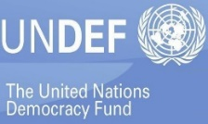

Background
The world is facing an ambitious SDG target: to end extreme poverty and halve poverty in all its dimensions by 2030. This vision is central to the work of national governments, as well as the worldwide community. Now urgent action is needed to achieve it!
Even though poverty reduction, including child poverty, has been in the focus of the Government of Armenia since the 90s, 29.4% of Armenians are still living in poverty, while 1.8% in extreme poverty, and the levels of poverty have not decreased to the former lowest level of poverty in 2008. An alarming characteristic of poverty in Armenia is the fact that around 25% of the poor adults are employed people, i.e. they work, receive a (low) salary, but are still poor. This may be an indicator of a number of drawbacks in the economy, such as inefficiencies in the labour market and low labour productivity, low wages, including the low rate of economic participation of women.
No one is more vulnerable to poverty than children, both girls and boys. Every third child in Armenia is currently living in poverty (34.2% child poverty rate, with 2% extreme child poverty rate). Geographical disparities also are high, with every second child (50.9%) in Shirak region living in poverty. Child poverty rates substantially vary depending on the number of children in the household, the age group of the youngest child, as well as on the characteristics of the household head such as gender, educational level and employment status.
Poverty is also multi-dimensional. Significantly, the most important deprivation, in terms of the number of adults affected, is labour (deprivations related to labour force participation, unemployment or quality of employment), followed by housing (affecting 1 million Armenians), and health (almost 700,000 individuals). One in three children, both girls and boys, in Armenia are both poor and deprived (25.2%). Every second child is multi-dimensionally poor/deprived (57.4%), particularly in utilities, social interactions and leisure. One-third of children, boys and girls alike, in Armenia are deprived but not poor (32.2%).
Children and adolescents growing up in poverty, especially extreme poverty, require special attention. They are affected by poverty in different ways than adults and are almost certain to miss out on a good start in life. The consequences of inadequate nutrition, a lack of early stimulation and learning, and exposure to stress last a lifetime. It leads to stunted development, low levels of skills development needed for life and work, limited future productivity as adults, and transmission of poverty down the generations. Beyond this tragic impact on human life and potential, neglecting children also fails to build the human capital needed for sustained economic prosperity in today’s world.
“There is no time to lose. By putting children at the forefront of the poverty agenda, we can lift millions of children out of poverty and accelerate progress across other crucial [SDG] goals.”
Stimulating economic growth is critical to eradicate poverty, but this is not enough. Concerted efforts and a package of policies will be necessary to: promote more inclusive growth, including education and labour market policies to allow the younger generation to find decent work; and, achieve more regionally-balanced development, through a more equitable distribution of basic services and infrastructure across the country. However, economic development of any country does not automatically reach the poorest – disparities are widening. Moreover, girls and boys who are poor today cannot wait for prosperity, they need to grow and develop today!
Social protection plays a vital role in strengthening the resilience of children, families and communities, achieving greater equity, and supporting national human and economic development. Targeted interventions can reduce the impact of poverty on girls and boys, and can improve their chances in life. The overarching principle of the 2030 Sustainable Development Agenda is that of ‘leaving no-one behind.’ This requires greater emphasis on delivering benefits to the most vulnerable groups of people, including those living in poverty, girls and boys (in institutions, with disabilities or at risk of neglect or abuse), the elderly, and persons with disabilities.
“Every child has the right to a standard of living adequate for the child's physical, mental, spiritual, moral and social development…States Parties shall take appropriate measures to assist parents and others responsible for the child to implement this right and shall in case of need provide material assistance and support programmes (art. 27, CRC)”
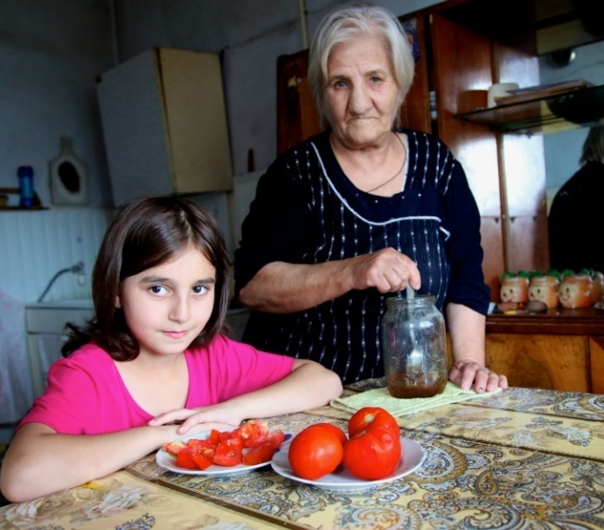
Investing in children and adolescents, girls and boys alike, is key; however, investment in their families is equally important. The amount of money available in a household plays a crucial role in determining the opportunities a child may have in life. Various types of cash benefits have an impact on child poverty reduction, especially extreme poverty. The family benefit (FB) scheme is the largest support programme to poor families in Armenia. While the coverage of the population by the FB in Armenia is stable (13.6% of the population in 2016), its targeting needs improvement, so that the poorest and most disadvantaged are not left without essential support. Simultaneously, the size of cash transfers should be adequate to the needs that they aim to cover, have a more vivid poverty reduction objective, and be more child oriented. Moreover, cash benefits and different types of services should be interlinked and coordinated with early learning, education, health, and other services that benefit children and address their multiple vulnerabilities. Social protection should also be clearly connected to labour market activation policies, ensuring painless transfer of beneficiaries from the social protection system to an active labour market force and ensuring their resilience.
Due to the multi-dimensional nature of poverty, monetary assistance programmes are not the only forms of interventions needed by the poor, especially poor families and children. Social support and care services are therefore an important component of social protection. Since 2010, the Government of Armenia, with the support of UNICEF, the World Bank and other actors, has embarked on the reform of integrated social services (ISS) in the country, introducing integrated social centres (ISCs), individual case management, local social planning and cooperation among social service providers. There are 20 ISCs at the moment with a rollout plan of 34 more across the country – the centers are venues where social protection programmes and services are provided through a “one-window” approach. This means that the citizens can access all the information they require about programmes and services (including pensions, employment services, social assistance services and disability benefits) in the same place. Individual case managers play an important role in this process, by identifying the needs of individuals and households, and addressing these by mobilizing the community and support network around them, and facilitating access to services. A professional social work cadre ensures that the voices of citizens are heard in decision-making, promoting social justice and empowering them to contribute to the society, improving not only their personal economy and wellbeing, but also the country’s economy at large. To function properly, case management and social work requires not only recognition, full capacities and professionalization, but also an adequate network of local social support services (e.g. for children, families with persons with disabilities, and the elderly). However, challenges remain in systemic capacity development and quality of social/case management work, availability and quality of community-based services, financing of social protection, as well as professional cooperation among social service providers in addressing the multiple vulnerabilities of families and their children. Financing of social protection is a key element of building the system. The sector should not be viewed as a spending, but as an investment in human capital.
Investing in children through better healthcare, nutrition, education, water and sanitation, leisure, sports activities and social protection is one of the best ways to allow children to fully develop and thrive. These investments – as part of the global SDG agenda - have demonstrated benefits for children with high returns, especially when started from an early age, and they can make a lasting difference to ending child poverty. Lifting children, girls and boys alike, out of poverty will make a huge positive difference to their lives, and those of the families, communities, and the society.

