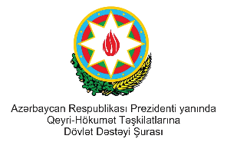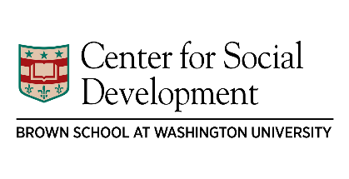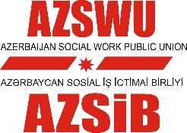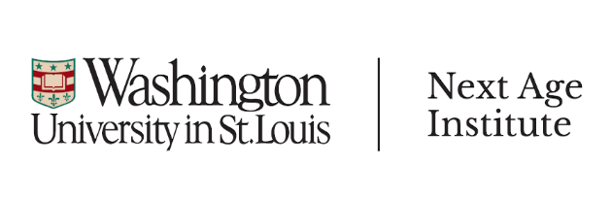

CONFERENCE PROGRAM OF
CHILD DEVELOPMENT ACCOUNTS: NEW APPROACH TO CHILD WELL-BEING,
BAKU, AZERBAIJAN, 6 NOVEMBER, 2018

TIME | PRESENTATION | PRESENTER
9:00 – 9:30 | REGISTRATION
9:30 – 10:00 | Opening remarks | Representatives from NGO Council of Azerbaijan, ADA University, Ministry of Labour and Social Protection, State Committee for Family, Woman and Children Affairs, Ministry of Education
10:00 – 10:30 | Child Development Accounts: Research and Policy Design | Professor Michael Sherraden, George Warren Brown Distinguished University Professor Director, Center for Social Development, Director, Next Age Institute, Washington University in St. Louis
10:30 – 11:00 | Child Development Accounts in Israel | Professor Daniel Gottlieb, Head of Research & Planning, National Insurance of Israel and Baerwald School of Social Work and Welfare, Hebrew University of Jerusalem
11:00 – 11:30 | BREAK
11:30 – 12:00 | Child Development Accounts in Greater China: Policies and Programs in Taiwan, Hong Kong and Mainland China | Li Zou, MSW, MBA, International Director, Center for Social Development (CSD), Next Age Institute (NAI)Washington University in St. Louis
12:00 – 12:30 | Child Development Accounts in Singapore | Professor Michael Sherraden
12:30 – 13:00 | Possibility of Child Development Accounts Policies in Post-Soviet Countries: Policy Design for Azerbaijan | Aytakin Huseynli, Chair of AZSWU, PhD Student at Washington University
13:00 – 14:00 | LUNCH
14:00 – 14:30 | Child Development Accounts Policy Diffusion: Examples from Korea | Li Zou, MSW, MBA
14:30 – 16:00 | Speakers from Turkey, İran, Moldova, Kazakhstan, Ukraine & Mongolia will present on financial stability/support policies of their countries for children | TBC
16:00 – 16:45 | Q&A session with keynote speakers at panel | Keynote speakers
16:45-17:00 | Closing remarks | Facilitator

