Fifth Congress of Social Workers of the post-soviet countries “Social work as a tool to promote the image of social work”
&
FIRST CONGRESS OF SOCIAL WORKERS OF SIBERIA
"SOCIAL WORKERS OF SIBERIA – THE key to SOCIAL WELFARE OF THE POPULATION "

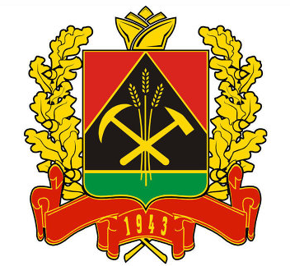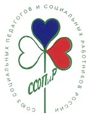

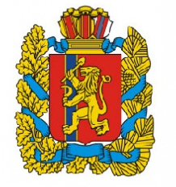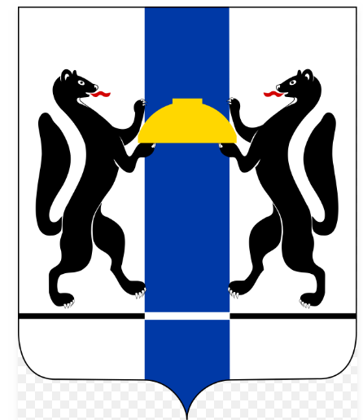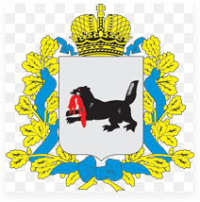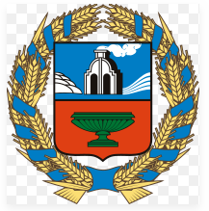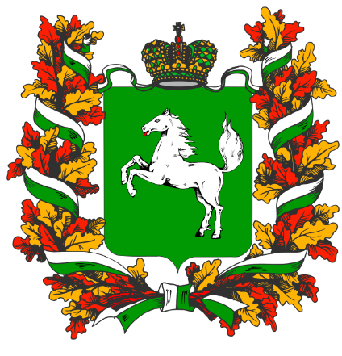

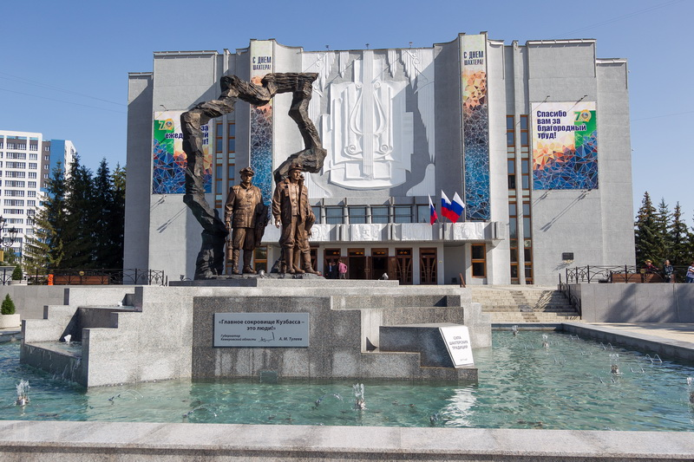
THE PROGRAM (DRAFT)
April 22-24, 2019
Kemerovo

21 April – departure from Moscow
21.25 – from Sheremetevo
22.20 – from Domodedovo
The 22nd of April

The arrival of the participants early in the morning
Accomodation will be in hotel Kuzbass

13.00 – 17.00
Visits to social services institutions
Visiting social service institutions of Kemerovo (you can choose 2 of those to visit)
Center for the rehabilitation of children and adolescents with disabilities "Flamingo"
The social and rehabilitation center for minors "Little Prince"
Kemerovo house for the elderly and people with disabilities
Complex center of social services for the population of Kirov District of Kemerovo

The 23rd of April

Plenary session and round tables
8.30–09.30 |  | Registration of the participants  Participants: social workers of the Siberian Federal District, other parts of Russia, foreign guests
9.30–10.00 |  | Registration  At the hall there will be exhibition of social service institutions form Kemerovo
10.00-13.00 |  | Plenary session (simultaneous translations will be provided)  Welcome speech:  - Tsivilev Serghei - Governor of the Kemerovo Region  - Representative of the State Duma of the Federal Assembly of the Russian Federation from the Kemerovo Region or the Council of Federation of the Federal Assembly of the Russian Federation from the Kemerovo Region  - Daniel Mathieu - Social and Gender Equality Counselor at the French Embassy in Russia  - Dashkina Antonina - President of Russian Union of Social Workers and Social Pedagogues  Presentations:  - Social services of the Kemerovo Region: main activities  - The professionalism of social services staff - the key to the effectiveness and quality of social services for the population  Showing uniforms of social services professionals of the Siberian Federal District, the performance of regional hymns, the demonstration of the film "Social Services of Siberia"
13.00-14.00 |  | Buffet lunch
14.00-16.30 |  | Round tables (will be held simultaneously) – translation to those who need it will be provided  - “Dementia: impossible to prevent and impossible not to act. The role of social services in working with people suffering from dementia and their relatives"  Leading:  Voronina Elena, Head of the Department of Social Protection of Population of the Kemerovo Region  - "Approaches to assessing the quality and availability of social services to the population"  Leading:  Sumin Adar, Minister of Labor, Social Development and Employment of the Republic of Altai  - " Regions of Siberia as the territory of a happy childhood "  Leading:  Osikina Natalia, Minister of Social Protection of the Altai Region,  - "The setting up a regional system of long-term care: organizational and legal components"  Leading:  Rodionov Vladimir, Minister of Social Development, Custody and Guardianship of the Irkutsk Region,  - "Rural social workers of Siberia: problems and successful experience in the provision of social services to the population in the Russian province”  Leading:  Pastuhova Irina, Minister of Social Policy of the Krasnoyarsk Region,
19-00 |  | Visit to the Kuzbass Musical Theater (operetta)
The 24th of April

Plenary session and round tables

09.30-12.00 | Round tables (will be held simultaneously)  - "Socially-oriented NGOs, social business, state social services = partners or rivals"  Leading:  Frolov Iaroslav, Minister of Labor and Social Development of the Novosibirsk Region,  - "Stationary replacement technologies and new forms of stationary social services"  Leading:  Kuprianov Vladimir, Minister of Labor and Social Development of the Omsk Region,  - "Creating conditions for active aging: the role and capabilities of social services"  Leading:  Kinyaikina Marina, Head of the Department of Social Protection of the Tomsk Region,  - “The future of a welfare state without poverty”  Leading:  Tas-ool Ludmila, Minister of Labor and Social Policy of the Republic of Tyva,  - “Thinking about the elderly - we are thinking about the future”  Leading:  Diyachenko Natalia, Acting Minister of Social Protection of the Republic of Khakassia  - Fifth Congress of Social Workers of the post-soviet countries “Social work as a tool to promote the image of social work. The contribution of social workers to public diplomacy and the strengthening of friendship between nations” (The congress is attended by representatives of associations of social workers from the post-soviet countries - Armenia, Azerbaijan, Belarus, Georgia, Kazakhstan, Kyrgyzstan, Tajikistan, Moldova)  Leading:  Dashkina Antonina - President of Russian Union of Social Workers and Social Pedagogues  Tarna Vadim – President of National Association of Social Workers in Moldova |  | СМОТР СОЦИАЛЬНЫХ ПРОЕКТОВ «NON-STOP»  Презентации российских и международных социальных проектов и программ с активным вовлечением в обсуждение каждого из представленных проектов представителями общества, бизнеса и власти  (по отдельной программе)
12.00-13.30 | Lunch
13.30-15.30 | Plenary session  Drawing conclusions  Presentations of the leaders of the round tables  Signing a memorandum on the creation of the Social Alliance of Siberia  Awarding the best social workers of Siberia with the badge "The Best Social Worker of Siberia" and gratitude from the State Duma or Federation Council of the Russian Federation
15-30 -16-00 | Concert
16.00-17.00 | Buffet
The 25th of April

 | The departure of the participants
 | 6.15 AM departure to Moscow arriving to Sheremetevo at 7.15 AM
 | 7.40 AM departure to Moscow arriving to Domodedovo at 8.10 AM

