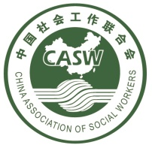
China Social Work Development Report 2018-2019

The year of 2019 is the 70th anniversary of the founding of China. With the development of the past 70 years, China's economy has made great progress and the people's living standard has been improving continuously, which has made higher demands on the development of social work. In his 2019 Report on the Work of the Government, Premier Li Keqiang proposed to guide and support the healthy development of social organizations, humanitarian relief, voluntary service and philanthropy. China Association of Social Work (CASW) summarized the development status of China's social work industry in 2018. At the same time, the relevant social work activities during the International Week of Social Work were summarized and collated in 2019.
- The State shall formulate relevant policies to promote the in-depth development of social work
Looking back the year of 2018, the term of "social work" has been written in the government report four times, and in the 2018 Report on Government Work, the term of "Promotion of social organization, professional social work, voluntary service healthy development” to describe social work.
From January to June 2018,The Ministry of Civil Affairs issued《Case Work On Social Work Methods》, 《Work Of The Working Group On Social Work》, 《The Guide Of Social Work Service On Youth》related policies.
On April 1st, 2018,《The Evaluation Measures For Senior Social Workers》developed by the Ministry of Human Resources and social security and the Ministry of Civil Affairs began to be implemented.
On June 2018, the Ministry of Finance issued《Measures For The Administration Of Government Purchase Services (draft for comments),Government Purchase Service Policy》，which brought about a number of changes to the Government's policy on purchasing services.
On September 26st, 2018，The CPC Central Committee and The State Council Strategic issued 《Plan For Rural Revitalization (2018-2022)》, the introduction of social work professionals and volunteers to provide care services for children and women left behind in rural areas, the elderly and children in difficult circumstances was proposed.
On September 27st, 2018, The Ministry of Civil Affairs issued《Classification And Evaluation Of Pension Institutions(Draft For Comments)》, Social work has been included in the star rating standard, which has promoted the continuous improvement of the service quality in the old-age institutions.
On October 16st, 2018, The National Health Commission released《Evaluation Index Of the Action Plan For The Further Improvement Of Medical Services (2018-2020)》,which established medical social workers and volunteer systems.
On March 19st, 2019, The Ministry of Civil Affairs of China released about the symbol of "social work in China" which is important measures to build overall social work. In order to strengthen social work publicity. Optimizing the development environment and promoting brand building.
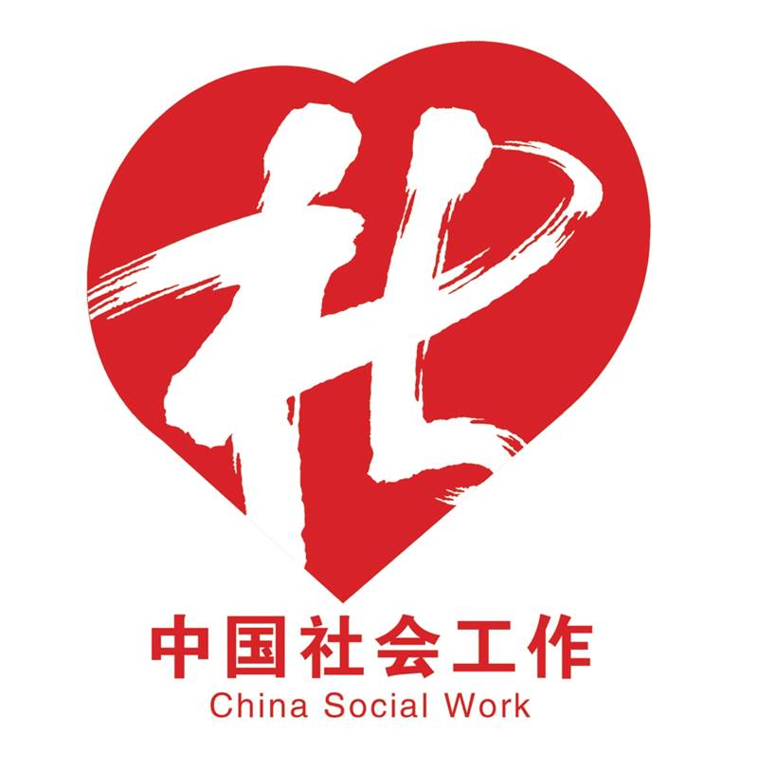
Figure 1 China social work logo
To view the original information, please click:
http://news.swchina.org/industrynews/2019/0321/33468.shtml
http://laws.swchina.org/policy/2019/0306/33307.shtml
- Relevant activities of the CASW
According to 《The Notice Of The General Office Of The Ministry Of Civil Affairs On Organizing The Publicity Activities On Social Work Themes In 2019》related to the deployment of work, To promote social work to take an active and proactive role in participating in the fight against poverty, supporting the rejuvenation of villages, serving the underprivileged, coordinating social governance and so on, and win social recognition and recognition for its good professional image and outstanding service effect, In order to achieve the all-round development of social work with Chinese characteristics on the basis of the new starting point and the new journey, CASW has launched the following series of publicity activities on social work during the "Social Work Publicity Week":
- The theme of “I speak for the social workers”
CASW Carried out the theme of "I love social workers, I speak for social workers." online interactive activities to pay tribute to social work, and advocate the concept of social work.
- The report of Social Work Industry
CASW released China Social Work Development Report in 2018, a comprehensive demonstration of the development of social work process by the data and trend analysis.
- The book of Social Work industry proposal
CASW issued the year of 2019 Social Work industry development proposal, advocating the integration of social workers into the great era, practicing the industry mission, and promote social development.
- Carrying out the mission of "poverty alleviation and relief"
CASW practiced the theme of "New Dream Pursuit, Social Work In Action", Responding to the call of the social organizations to take an active part in the fight against poverty, they went to the designated project villages in Lianhua County, Jiangxi Province, and donated funds to discuss plans for the rehabilitation of rural communities and promote the implementation of the Good Community Plan.
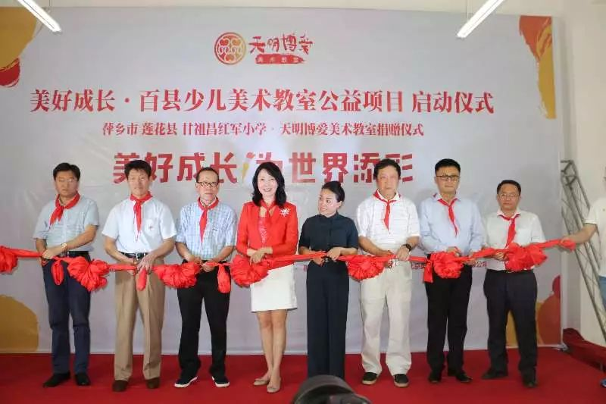
Figure 2 Wonderful community initiation ceremony
- The activity of “tell a good story about social workers”
CASW invited representatives of all sectors of the community, launched the "Tell The Story Of Social Workers" subject research and social advocacy project, held first expert seminar.

Figure 3 Daily work of medical social work service
- Supporting local social work publicity activities
The leaders of CASW went to different regions and participated in the thematic publicity activities of social work in different areas by in different forms.
- Call on secondary institutions to organize professional awareness-raising activities
All Offices, Professional Committees and Special Funds were held during the publicity respectively. Social work publicity and advocacy activities in various professional fields and displayed on the website in "Social Workers in China ".
To view the original information, please click:
http://news.swchina.org/trends/2019/0313/33356.shtml
- Local level
In order to Celebrate the 13th International social work day, carrying forward the spirit of social work, disseminating knowledge of social work, and raising the awareness of the general public of social work, Gansu, Jiangxi, Shanghai, Guangdong, Hubei, Shenzhen and Inner Mongolia and many other provinces held the theme of social work around the "new journey of dreaming, social workers in action"，celebrations were carried out. This publicity campaign, on the one hand, it has raised the level of public awareness of social work, on the other hand, it has promoted the development of local social work.
Social work is adhering to the " Help Others By Helping Oneself" principle of service and "respect, acceptance, equality, tolerance, integrity" value concept, social work occupation meeting residents needs for Service by Professional Methods, social work pays more attention to the psychological assistance and social support needs of the clients, and puts more emphasis on helping the clients repair and upgrade the social adaptation, social interaction and social development abilities. The publicity of this week's Social Work Week is diverse, pragmatic and efficient in every local area. The publicity of social work has increased, , the influence of social work in China has been increased in a certain extent, which has contributed to the development of social work in China.
To view the original information, please click:
http://special.swchina.org/190318/swchinasocialworkerweek3.shtml
By the end of the year of 2018, localities in urban and rural communities related institutions and social organizations and other organizations settings 383,000 social work professional posts, an increase of 37,000 over 2017. In addition, the national social work service station has reached 51,000.
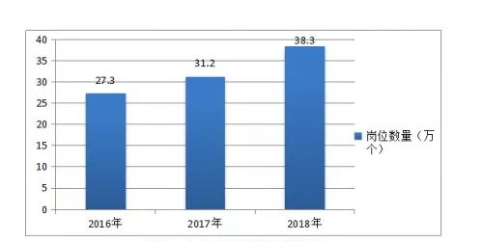
Figure 4 Trends in the growth of social work jobs
The number of social work associations has increased significantly. By the end of 2018, there were 34 provincial, 241 prefecture-level and 592 county-level social work associations total 867, an increase of 14.7% over 2017.
The number of social work industry associations increased significantly. By the end of 2018, there were 34 provincial, 241 prefecture-level and 592 county-level social work associations amounted to 867, an increase of 14.7% over 2017.
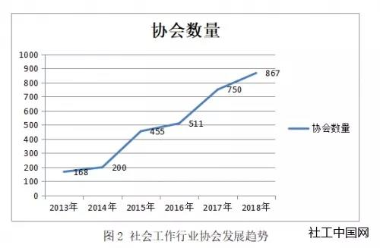
Figure 5 Trends in the number of social work associations
The number of social work service institutions continued to grow. By the end of 2018, a total of 9,793 social work service organizations had been established in various localities. Compared with more than 500 private social work service agencies in Jiangsu, Zhejiang and Sichuan provinces in 2017, the number of private social work service agencies reached 432 by the end of 2018.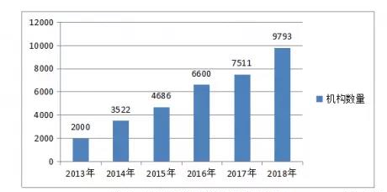
Figure 6 The trend of social work service institutions
Under the background of the 19th Congress of the Communist Party of China, it is necessary to strengthen the construction of the social governance system and improve the level of social governance, and to vigorously promote the development of social work. Social workers embed the social security system, community sanitation, community cultural connotation, community employment and so on in different levels, angles and ways to foster and cultivate the social forces to realize their potential. CASW will continue to work with you to develop professional services and promote the development of the social work industry.
To view the original information, please click:
http://news.swchina.org/industrynews/2019/0321/33468.shtml

