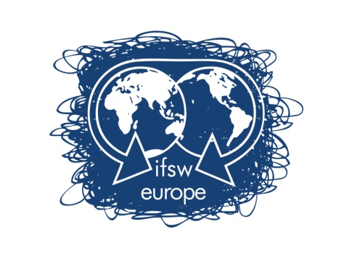 | FUNDING RULES FOR  DELEGATES MEETING VIENNA  6th -7th -8th September 2019

IFSW Europe e.v. is glad to inform on the process to apply for financial support to attend IFSW Europe Delegates Meeting 2019, which will be held in Vienna on September 6th – 8th.
Any delegate who wants to apply for economic support must:
- Fill in the application form
- Send it to IFSW Europe Treasurer, (bauslander@gmail.com) before 31 of July 2019.
- Applications must be accompanied by a letter from the IFSW Europe member organisation:
- Confirming their support for the applicant’s attendance at the meeting,
- Informing on the applicant’s position in the member organisation
- Explaining the financial situation of the organisation

In allocating the funding consideration will be given to the following:
- Whether the IFSW Europe organization has paid their annual fees for 2018 and 2019 to IFSW Europe e.V.
- Whether the applicant or any other member from the organisation has received funding previously.
- IFSW Europe will only support one member from each organisation

The criteria should be to fund only those member organisations who would otherwise be unable to send a delegate to the Delegates’ Meeting because of financial constraints

The financial support offered to member organisations to attend the annual Delegates’ meeting should be fixed at a maximum of €300 per organisation for covering :
- Travel (airfare),
- Visa
- Accommodation during the days of the Delegates meeting at the hotel suggested by the host organisation or in the same amount of the cost of those rooms.

In order to allow early bookings of flights and accommodations, applications must be received by IFSW Europe e.v. Treasurer, Brian Auslander, (bauslander@gmail.com) before 31 July 2019 at 12h00 GMT.
Please send all documents by email.
The decisions of IFSW Europe executive will be communicated no later than 10th of August 2019.
If you have any doubt, please do not hesitate to contact me,
On behalf of the IFSW Europe e.V. Executive Committee

Brian Auslander
Treasurer of IFSW Europe e.V.
Email: bauslander@gmail.com
Phone: +972 54 4453884

APPLICATION FORM FOR FUNDING SUPPORT

DELEGATES MEETING VIENNA
6th -7th -8th September 2019

Applications must be received by IFSW Europe e.V. Treasurer, (bauslander@gmail.com) before 31 of July 2019 at 12h00 GMT.
Applicant’s Name:_________________________________________________________________

- Applicant’s address: ______________________________________________________________
_____________________________________________________________________________________

- E-mail address: __________________________________________________________________

- Phone Number: _______________________________________

- IFSW member organisation: _________________________________________________________

- Could you explain why do you want to attend the Delegates Meetings? (max 150 words)
_______________________________________________________________________________________

_______________________________________________________________________________________

- Could you explain how your participation on the DM will impact on your organization? (max 150 words)

_____________________________________________________________________________________

_____________________________________________________________________________________

Note that the application form must be accompanied by a letter from the applicant’s organisation confirming their support for the applicant’s attendance at the meeting, including information on the applicant’s position in the member organisation

