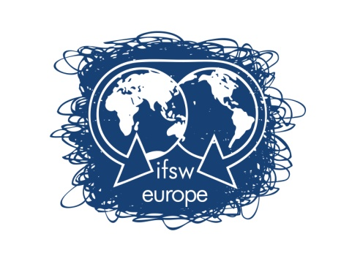

Call for expressions of interest to host the
IFSW European Conference 2023

International Federation of Social Workers
European Region e.V

IFSW Europe is calling for expressions of interest from member organisations willing to host the 2023 IFSW European Conference.

The aim of the Conference is to bring together social workers, researchers, and policy makers to share their experiences, common problems and focus on strategies at European level.

Closing Date for Applications: 3th February 2020
Expressions of interest are to be submitted to the President of IFSW Europe:
Ana Rădulescu
Email:
europe.ifsw@ifsw.org

Application Material
The submission of the expression of interest must contain a written agreement of the national organisation.
Expressions of interest must address the items identified in Appendix 1.
Process
IFSW Europe e.V. calls for expressions of interest to their members. Expressions of interest must be submitted before 3th February 2020.
The IFSW Europe Executive committee will review the submissions by 20 of March 2020, distributing the applications received to all member organisations as soon as possible after this date.
IFSW Europe Executive Committee will make recommendations to prioritise the expressions of interest received, considering the following;
- The good standing and fully compliant with IFSW regulations;
- The financial viability and organisational capacity of the host organisation(s);
- The level of anticipated local participation and support for the IFSW European Conference;
- An indicative budget which demonstrates an understanding of the elements of conference planning;
- Indicative themes;
- Proposed venue, including ways of access to the venue from all parts of Europe;
- Proposals for fieldwork visits/dislocated workshops;
- Proposals for social events;
- Capacity for translation;
APPENDIX 1
APPLICATION TO HOST THE IFSW EUROPEAN CONFERENCE 2023

Proposed Host Country………………..………………..………………..…………

Name(s) of national member organisation(s):
IFSW Member(s) ………………..………………..………………..………

Please provide a description of proposals under each of the following headings
- Proposed Venue
  - City
  - Airport and other travel options, including access availability from all parts of Europe
  - Conference location
  - Capacity
  - Facilities
- Interpretation facilities
- Social activities
- Fieldwork visits/dislocated workshops
- Accommodation capacity
  - Range of options including home stay, budget, medium and upwards
- Local administrative support, including the national hosts’ local representation

Proposed Themes
Please describe any proposed theme and note that this is indicative only at this stage

Indicative Budget
The indicative budget should contain the following details
- Estimates set at various participation levels, e.g. 400, 500, 800 participants.
- Any costs known at the time of submission venue costs, standard rates for translation and interpretation, travel costs for keynotes, etc.
- An indicative budget, which covers, all anticipated expenditures and sources of income, including levels of participants fee and costs of accommodation.

Representation
The conference organisers, called ‘Hosting Committee’ should ensure that all nationals of Europe will have easy access to the host country, including information about any visa-regulations.
Organisational Roles
Please provide a statement of respective roles of local member organisations. Are you the organisation accepting liability for the conference or is the liability to be shared and how?
Please describe the proposed local management process. At this stage a broad outline of the committee structure and numbers of representatives from each organisation is sufficient. Principles governing the establishment of the planning committees require equal representation from participating organisations and the appointment of co-chairs.
Professional Conference Organisers (PCO)
Please indicate whether you intent to make use of a Professional Conference Organiser.
Please ensure that you do not sign any contract with a Professional Conference Organiser without prior discussion and approval from IFSW Europe.
Declaration
The Executive Boards of ………………………………………………….. (INSERT Organisational Name(s)) have approved this submission to host the 2023 IFSW European Conference.
IFSW Europe and the hosting organization(s) will accept mutual financial liability for the conference.

Signed …………………………………
President
For ………………………………………
Date …………………..

