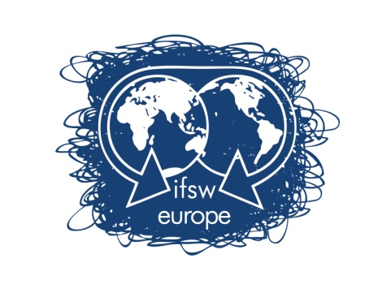 | Work programme 2020-2021

This work programme is presented within the framework of The Global Agenda of IFSW under the following broad subheadings:
- Visibility and Voice
- Membership development
- Services for members.

IFSW commits to work wherever possible with people who use social work services to develop and implement its activities.

The priorities for 2020-2021:

1. COMMUNICATION
OBJECTIVES
  - Increase Online Visibility
Knowledge sharing – organise webinars and publish about the activities of our member organisation
  - Increase Internal Communications
Increase the contribution of member organization to the activity of IFSW Europe Representatives;
  - Increase communication with IFSW Europe partners
Ensure continuity between IFSW Representatives and our partners;

2. FINANCES
OBJECTIVES
2.1. Prepare applications for external funds and access external resources for specific activities;
2.2. Identify other financial sources to support the IFSW European members;
Ensure efficient management of IFSW Europe finances

3. MEMBERSHIP DEVELOPMENT
OBJECTIVES
3.1. Support member organizations to develop more active arrangements for mutual support and development, such as monthly webinars for our members to facilitate sharing and learning
3.2. Develop social work professional networks for peer support and learning

4. IFSW EUROPEAN CONFERENCE
OBJECTIVES
4.1. Provide the necessary support to members for organizing IFSW conferences.
4.1. Ensure the visibility of the IFSW European conferences;
5. IFSW Representatives
OBJECTIVES
5.1. Engage social workers in the work of IFSW Europe and to represent us in contact with our partners;
5.2. Ensure coordination between the IFSW Europe agenda and the activities of IFSW Europe representatives;

6. NETWORKING AND LOBBYING
OBJECTIVES
6.1. Engage with EU institutions (including the EU Commission and Parliament) and the World Health Organisation to further the voice of social work;

7. THE SOCIAL WORK DAY 2021
OBJECTIVES
7.1. Create and promote all over Europe common key messages within the Global Agenda theme of 2021;

8. RELATIONS WITH IFSW GLOBAL
OBJECTIVES
  - Ensure IFSW Europe representation to the IFSW Global Commissions;
  - Contribute to the Global Agenda for Social work and Social Development process

9. POLICY DEVELOPMENT AND SOCIAL ACTIONS
OBJECTIVES
9.1. Develop policy statements that reflect the priorities of IFSW Europe member organisations;
9.2. Develop the IFSW Europe website to include pages for member organisations to give feedback (testimonials) on the implementation of the European Pillar of Social Rights and the difficulties faced by social workers in its implementation.
9.3. Explore and develop positions on the growth of populism and other threats to human rights for the practice of social work and our role in promoting social justice
9.4. Identify the threats to human rights implicit in some national policies in relation to the delivery of social services during the covid-19 pandemic

IFSW Europe 2020

