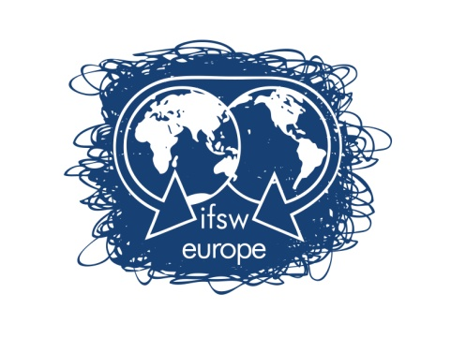
Treasurer’s Report 2025-2026

Our income and expenses are divided into operating expenses and projects. The annual operating expenditures are funded mainly by our membership fees and any profits from the regional conferences; the projects each receive funding from varied sources which is only used for the specific project. Some funding sources include IFSW global, the EU and NGO’s.

In 2025 our operating expenditures totaled €56,307.34 and the budget was €39,600.00. The discrepancy was due to additional, unavoidable and unexpected expenses for the delegate’s meeting, the expenses of travel to Oslo and Alta, as well as additional unexpected expenses for the legal body and accounting.

We began 2025 with a balance of €155,522.14 and ended the year with a balance of €111,404.22. Our total income was € 54,252.87 and we had expenses of € 98,233.99. These sums include income and expenditures from both the operating budget and projects. This expenditure includes payments for the Responsive project that are being recouped in 2026.

Regarding 2026, the beginning bank balance was €111,404.22. As of this writing, we had income of €62,484.34 and expenses of €59,490.78. The bank balance as of this date is €114,186.06. We have collected €33,310.34 in membership fees exceeding our budgeted goal of €30,000. We have also received €29,172.00 as our share of the profits from the Oslo conference. As previously noted, we are expecting to receive an additional payment to cover expenditures for the Responsive project of c. €36,000.

Our operating expenses are rising each year. This is mainly due to large increases in travel costs (from more activity but also from inflation), the cost of venues for the delegate’s meetings and technical expenses to hold hybrid meetings. The executive also wants to increase the visibility of IFSW Europe by increasing the budget for representative travel. These issues will be seen in the budget to be approved by the delegates for 2027.

Submitted by:
Brian Auslander, Treasurer
 | 2025 budget | 2025 income and expenses | 2026 budget | 2026 income and expenses (to date)
Starting Bank Balance  As of January 1 | 155,522.14 | 155,522.14 | 111,404.22 | 111,404.22
Income
Membership fees | 30,000.00 | 31,307.55 | 30,000 | 33,310.34
Responsive project | 12,248.25 | 12,248.25 | 15,000
Conference 2025 |  |  | 25,000 | 29,172.00
SSWAE project | 10,000.00 | 10,697.07
COCOSO project |  |  | 10,000
Total income | 207,770.39 | 209,775.01 | 181,504.22 | 173,886.56
Expenditure
Executive Travel | 12,000 | 15,869.44 | 12,000 | 11,993.93
Delegates Mtg | 6,000 | 16,078.05 | 6,000 | 0
Delegates subsidy | 4,000 | 2,775.80 | 4,000 | 0
Bank charges | 100 | 95.00 | 100 | 67.00
Representative travel | 4,000 | 3,406.31 | 4,000 | 2,214.59
NGO fees | 1,500 | 1,513.00 | 1,500 | 968.00
Honorary Secretary | 4,000 | 3,332.00 | 4,000 | 2,997.00
Auditor | 4,000 | 4,784.95 | 4,000 | 613.79
Legal Body | 4,000 | 7,624.80 | 4,000 | 1,562.75
Office Expenses | 0 | 827.99 | 400 | 441.58
Total Operating Expenses | 39,600 | 56,307.34 | 40,000 | 20,184.35
New Social Worker project/network | 3,004.32 | 486.93 | 8,000.00 | 678.00
Eco Social Work project | 2,321.29 | 2,017.18 | 0
SSWAE project | 10,697.07 | 1,881.00 | 8,816.00 | 6,009.25
Responsive project | 55,036.18 | 37,541.54 | 17,494.54 | 30,829.75
COCOSO project |  |  |  | 1,789.43
Total Projects Expenses | 58,040.18 | 41,926.65 | 34,310.54 | 39,306.43
Total Expenditure | 98,140.18 | 98,233.99 | 74,310.54 | 59,490.78
Balance | 109,302.21 | 111,541.02 | 107,193.68 | 114,395.78

