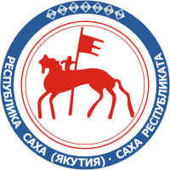 | 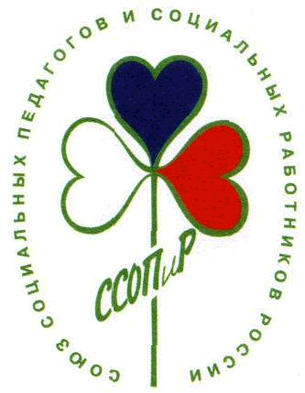 | 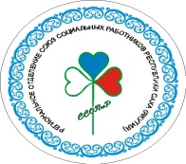 | 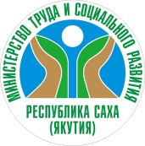

Dear International Friends !
I would like to inform you that 25-27 June 2020 Russian Union of Social Workers and Social Pedagogues together with the Government of Yakutia will hold the First Arctic Forum of Social workers “The Arctic is the territory of love and care”.
The main topics for discussions
- The best practices and projects of social services to people living in Arctic areas.
- Extreme situations connected with climate change: fires, floods etc. The role of social workers and social pedagogues in helping to prevent these events and to explain the public of the effects of the inappropriate treatment of nature.
- Social work with small groups of indigenous people.
- National projects of Russian Federation in raising social welfare of Arctic population (among those the programme “Children of Arctic”.
- International experience of quality tailored social services for vulnerable people.

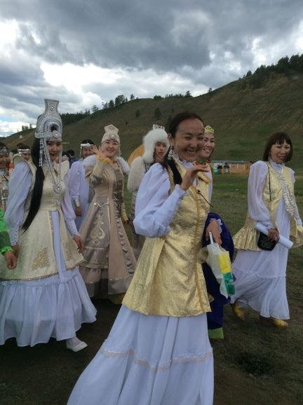
Yakutian Social Workers

Canada, Denmark, Finland, Iceland. Norway, Sweden, USA and Russia belong to the Arctic Council and 8 more countries are observers. The Arctic Council does not discuss social services and social work issues that is why it is the time to discuss the situation of climate change and severe conditions of life in these areas in 2020.
Yakutia is a very interesting area of Russia. The Sakha Republic (Yakutia) is in the north-eastern part of the Eurasian continent and is the largest region of the Russian Federation. The total area of the continental and island territory of Yakutia is 3,1 mln km². Over 40% of its territory is above the Arctic Circle. There are three time zones within its borders. Transversally, Yakutia’s length is 2500 km, longitudinally – 2000 km. The temperatures in the winter -50-60 C. In the summer – plus 25 C.

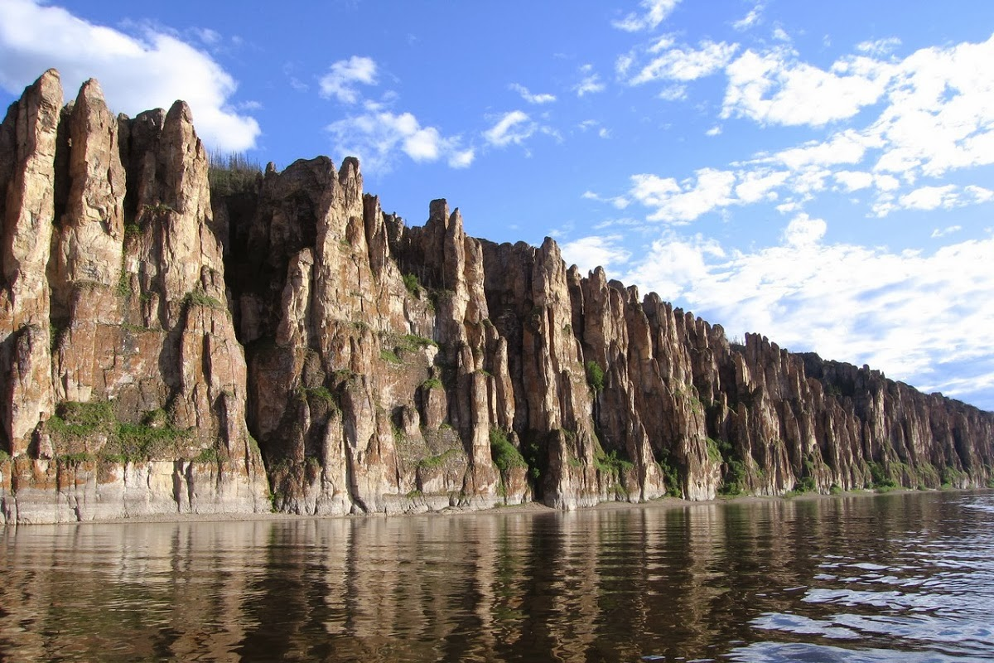
Lena River Pillars Yakutia (UNESCO World Heritage Site)
The Forum of social workers will take place in the city Yakutsk. June is summer there. The Forum will include the workshops discussions but also participation in the big and unique event – Ysyakh which is a cult celebration of nature rebirth, holiday of renovation held every year in the end of June. Central action of the festival is a competition of tellers of Olonkho – Yakut epos, acknowledged as a non-material legacy of UNESCO, Osuokhai dance, symbolizing the circle of life. The final action is the Sunrise meeting, signifying the clarification of the soul.
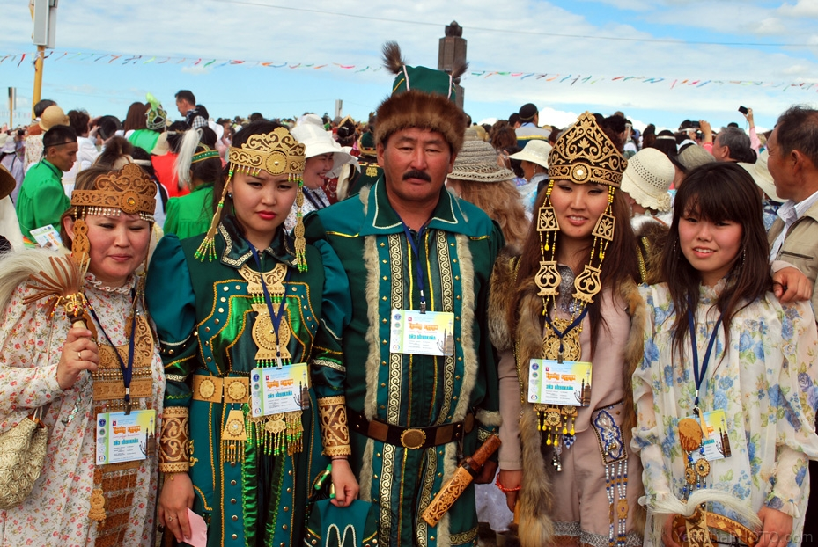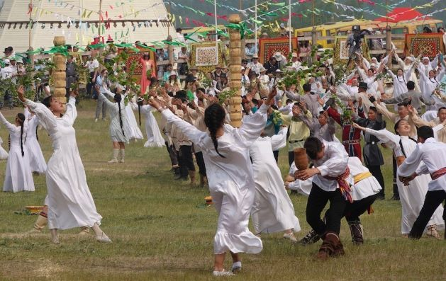
Ysyakh Celebration
How to get to Yakutsk
- Moscow- Yakutsk ( 3 flights a day – duration 6 hours 30 minutes)
- Seoul – Yakutsk ( direct flight 22 June-28 June, duration 4 hours 30 minutes)
- There are flights via Novosibirsk, Vladivostok
We recommend to buy tickets in advance as the price of the tickets will be growing closer to the summer time a lot.
Please check – if you need visa you will need to fill the form and send it to us in advance.

Dr Antonina Dashkina
President of Russian Union of Social Workers and Social Pedagogues

