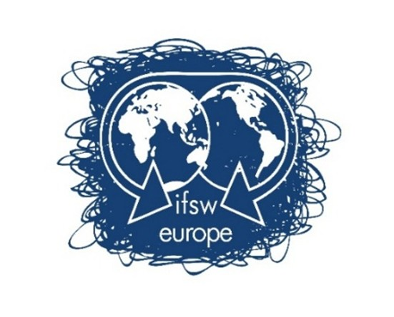

IFSW Europe Delegates Meeting

9-11 October

Agenda (draft V4)

LE:EN Restaurant/Venue
Heuveloord 140, 3523 CK Utrecht, Netherlands

Friday, 9 October (13:00 – 18:00)
Saturday, 10 October (09:00 – 18:00)
Sunday, 11 October (09:00 – 12:30)

Dear Colleagues

Welcome to the draft agenda for the IFSW Europe (IFSW E) Delegates’ Meeting 2026. Please note this version is subject to amendment and new versions will be posted on the DM webpage. The confidential link for the website has been sent via email to leads from each association. In case of difficulty accessing documents, email europe@ifsw.org

The meeting is open to delegates and observers from European member associations of IFSW E, representatives to European institutions, regional commissioners from global commissions and invited guests and experts.

Please note that, according to the IFSW Europe Statutes, each IFSW Europe member organisation is entitled to nominate 2 delegates to attend and a maximum of 3 observers. Only the delegates have the right to vote and there is only one vote per country.

Where two or more associations are members and entitled to attend as delegates, the two organisations must either agree which way they vote, or both abstain from voting.

Voting on general business matters will be by show of hands (raising flags) in the room and by ‘hands up’ function online. Voting on motions and Elections will be by confidential ballot - by paper in the room and by poll online.

We aim to have an effective technology to enable joining online, but we encourage as many of you to join in person as possible.

Friday, 9 October (13:00 – 18:00)

13:00 – 15:00
Arrival, refreshments and registration from 13:00

14:00
- Start of the meeting
  - Welcome and formal opening of the meeting by Co-Chairs President Ruth Allen and Vice President Andreas Kikvik
  - Check of register of delegates, observers, apologies, and quorum. Introduction of new attendees.
  - Approval of the Agenda by – show of hands/flags.
  - Approval of the minutes and Matters Arising from the Delegates Meeting 2024 – Vote
  - Introduction and roles of members of the Executive and call for election officer and tellers

- Overview of the agenda and procedures for the meeting including:
2.1.Notice of elections for Executive vacancies – Two Executives, two Deputies
2.2 Notice of appointment and renewal of Representatives
2.3 Ways of working together, where to get information online and within the meeting and protocols for participations
- Getting to know each other: fifteen minutes to speak to some participants you don’t know!
14.30 – 15.30
- Presentation and discussion of the IFSW Europe Annual Report of activities and achievements against the Strategy 2025/6 (30mins)
- Proposals for workplan 2027 (30 mins): Part One (to be updated following feedback and brought back for vote on Sunday morning)
15.30 – 16.00
BREAK
16:30 – 18:00
- Reports (45 mins)
6.1 Representatives within European institutions
6.2 Regional Commissioners
6.3 The New Social Workers Network

- Finance report (45 mins) Part One (to be updated following feedback. Any vote can be deferred and brought back on Sunday morning if clarification is necessary)
7.1 Treasurer’s report on expenditure and income 2025/6 – Vote on approval or deferred to Sunday
7.2 Auditor’s report – 2025 – Vote on approval or deferred to Sunday
7.3 Report on membership, fees collected, fee level for 2027 and members in good standing at global and European level
7.4 Proposed membership fee 2027 – for discussion (Vote on Sunday)
7.4 Proposed Budget for 2027 – for discussion (Vote on Sunday)
7.4 Establishment of fundraising and bidding expert group: for information
CLOSE at 18:00

Evening event 18:30

Invitation to dinner in the Le restaurant which is attached to the meeting venue

Saturday, 11th October 9.00 – 17.30
09:00 – 10:30
Arrival from 8.30am

9.00am – Welcome to Day Two

Welcome to IFSW Global President/Secretariat in person or by zoom: Global Update Report (15 mins)

- Reports, learning and outputs from current/recent projects (40 mins)
  - Responsive (EU funded project – closed with ongoing dissemination)
  - COCOSO (EU funded project - ongoing)
  - Strengthening Social Work Across Europe through IFSW (IFSW global funded - ongoing)

10. Proposed policy papers (30 mins)
11.1 New Social Workers Network: Proposed policy paper on intergenerational social work
11.2 UN Regional Commission: policy paper on social work and rights of older people
10:30 – 11:00 BREAK
11:00 – 12:15
11. Working conditions and wellbeing of social workers: Presentation and discussion of proposal for new workstream
12:15 – 13.30 LUNCH – delegates are free to choose their own place for lunch
13.30– 16.00
12. Parallel activities

Group one : Eco-social walk and talk (1 hr) and envisioning session in the main room (1.5 hours)
Group two: Discussion about AI and digital social work project proposals (1 hour) then walk and talk (1.5 hours)

Alternatives to a walk will be offered if the weather is not suitable and/or for anyone unable to participate in the walk.

16:00 – 16:30 BREAK
16:30 – 18:00
13. Summary feedback from the working groups and walk and talk (30mins)

14. Presentations and votes on member motions (60 mins)

18:00 Close

Sunday, 27th October 2024
09:00 – 10:30
- Conclusion of discussion and votes on member motions (if required)
- Final finance report and workplan 2027 – part two (30 mins)
  - Presentation and adoption of final Treasurers Report, Budget for 2027 – Vote
  - Presentation and adoption of final costed workplan 2027 – Vote
  - Appointment of auditors 2026
- Appointment of the representatives (30 mins)
10:30 – 10:45 BREAK
10:45 – 12:30
- Election of the European Executive: short presentations from each nominee followed by confidential ballot (45 minutes)
- Presentation and discussion of October 2027 Delegates Meeting and Conference in Athens, Greece (20 minutes)
- Update on 100th Anniversary IFSW Global General Meeting and Conference, Paris, July 2028

- Any other business
CLOSE OF MEETING by 12.30pm

