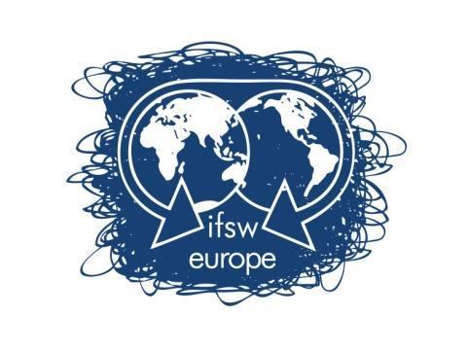

FUNDING RULES FOR

DELEGATES MEETING
9-11 October 2026, Utrecht, Netherlands

IFSW Europe is pleased to inform you about the process to apply for financial support to attend the IFSW Europe Delegates Meeting 2026 which will be held in Utrecht, Netherlands on 9-11 October 2026

Any delegate who wants to apply for economic support needs to:
- Fill in the application form (at the bottom of this document)
- Send it to IFSW Europe (europe@ifsw.org) and to the IFSW E Treasurer, (bauslander@gmail.com) by 23:59 hrs on 17th August 2026.
- Please include with the application form a letter (on headed paper if possible) from your IFSW Europe member organization. The letter must contain:
- Confirmation of the association's support for the named applicant’s attendance at the meeting
- Information about the applicant’s position/role in the member organization
- Explanation of the financial situation of the organization and why a subsidy is appropriate
- Include a detailed breakdown of the costs of attending the meeting including transportation expenses, accommodation and visa cost.

Please note IFSW Europe will only support one member from an organization to attend.

To allocate the funding, the following will be taken into consideration:
- Whether the IFSW Europe member organization has paid their annual fees for 2025 and 2026 to IFSW Europe
- Whether the applicant or any other member from the organization has received funding previously.
- Whether the applicant will be the only delegate from the organization.

Acknowledging that Utrecht is an expensive destination, the financial support offered to member organizations to attend the annual Delegates’ meeting will be determined based on the number of applications received. In other words, the executive will not set a maximum amount other than for accommodation. The budget will be divided among the applicants based on actual expenses, within the overall approved budget which this year is 4000 euros. IFSW Europe reserves the right not to spend all of the budget if there are insufficient eligible applications.

The delegate (or association) must pay the costs of attendance in advance and reclaim expenditure back from IFSW E based on receipts for:
- Travel including airfare, train or bus tickets
- Visa
- Accommodation during the days of the Delegates meeting at a hotel suggested by the host organization or at the same amount of the cost of those rooms.
Accommodation reimbursement will be fixed at up to 140 euros per night for up to four nights. Any accommodation costs above this must be covered by the individual or organisation.

All costs must be kept to a reasonable minimum and the reason the subsidy is needed must be clear in the application form.

The reimbursement process

The delegate or their association must pay the costs of attendance up front and reclaim expenditure totalling no more than the amount agreed in advance by IFSW Europe.

Reimbursement will be based on proof of travel/stays in Oslo and receipts for:
- Travel including airfare, train and/or bus tickets
- Travel Visa
- Accommodation of up to four nights including the days of the Delegates meeting at a hotel or other facility. It is the responsibility of attendees to ensure the accommodation they have chosen is suitable and safe.

PLEASE NOTE:
- Costs of food, travel insurance and other subsistence expenses will not be considered.
- IFSW Europe does not guarantee to cover all the costs of travel and accommodation expenses and the organisation will be notified in advance as to the level of reimbursement available.
- All attendees to the Delegates Meeting, including those receiving funding from IFSW Europe, are responsible for their own travel, health and other relevant insurance and indemnity arrangements.
- IFSW Europe takes no liability or responsibility for any negative incidents, harms, losses or other detriments incurred as a result of the travel and accommodation that is being reimbursed (in part or in full).
- The individual or organisation applying for funding will be notified in advance of the maximum level of reimbursement.

Applications must be received by IFSW Europe (europe@ifsw.org) and the IFSW Europe treasurer, Brian Auslander, (bauslander@gmail.com) by 23:59 17th August 2026

IFSW Europe may, at its discretion, reopen the call for a limited period after the deadline only if insufficient eligible applications have been received.

Successful applicants will be notified by 24th August 2026.

Please send all documents by email.

If you have any questions, please do not hesitate to contact me,
On behalf of the IFSW Europe Executive Committee
Brian Auslander
Treasurer of IFSW Europe
Email: bauslander@gmail.com
Phone: +972 54 4453884

APPLICATION FORM FOR FUNDING SUPPORT

DELEGATES MEETING

UTRECHT, NETHERLANDS
9-11 OCTOBER 2026

Applications must be received by email to IFSW Europe e.V. Treasurer, (bauslander@gmail.com) and IFSW E (Europe@ifsw.org ) by at 23:59 Central European Summer Time on 17th August 2026
- Applicant’s Name:_______________________________________________________

- Applicant’s address: _______________________________________________________
_____________________________________________________________________________________

- E-mail address: ________________________________________

- Phone Number: _______________________________________

- IFSW member organisation: _____________________________________________

- Could you explain why do you want to attend the Delegates Meetings? (max 150 words)
______________________________________________________________________________________________________________________________________________________________________________________________________________________________________________________________________________________________________________________________________________________________________________________________________________________________________________________________

- Could you explain how your participation on the DM will impact on your organization? (max 150 words)

___________________________________________________________________________________________________________________________________________________________________________________________________________________________________________________________________________________________________________________________________________________________

- Please detail the expected travel expenses (accommodation, return travel, visa)
__________________________________________________________________________________________________________________________________________________________________________________

Note that the application form must be accompanied by a letter from the applicant’s organization confirming their support for the applicant’s attendance at the meeting, including information on the applicant’s position in the member organization

