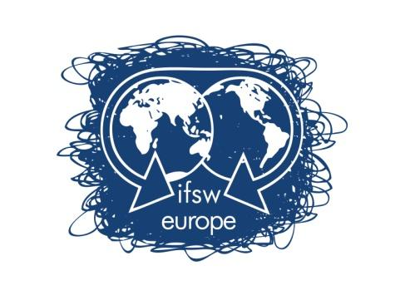 | FUNDING RULES FOR  DELEGATES MEETING  Birmingham  24th -25th - 26th April 2020
IFSW Europe e.v. is pleased to inform about the process to apply for financial support to attend IFSW Europe Delegates Meeting 2020, which will be held in Birmingham on April 24th – 26th.

Any delegate who wants to apply for economic support has to:
- Fill in the application form
- Send it to IFSW Europe Treasurer, (bauslander@gmail.com) before 30 of March 2020.
- Accompany the application with a letter from the IFSW Europe member organisation. The letter must contain:
- Confirmation of their support for the applicant’s attendance at the meeting
- Information about the applicant’s position in the member organisation
- Explanation of the financial situation of the organisation

To allocate the funding, the following will be taken into consideration:
- Whether the IFSW Europe organization has paid their annual fees for 2019 and 2020 to IFSW Europe e.v.
- Whether the applicant or any other member from the organisation has received funding previously.
- IFSW Europe will only support one member from an organization. To be clear, funding will be provided only to those member organisations who would otherwise not be able to send a delegate to the Delegates’ Meeting.

The financial support offered to member organisations to attend the annual Delegates’ meeting will not exceed €300 per organization. The support will be released based on receipts for:
- Travel including airfare, train or bus tickets
- Visa
- Accommodation during the days of the Delegates meeting at the hotel suggested by the host organisation or in the same amount of the cost of those rooms.

Applications must be received by the IFSW Europe e.v. treasurer, Brian Auslander, (bauslander@gmail.com) before 30 March 2020 at 12h00 GMT.

Please send all documents by email.

The decisions of IFSW Europe executive will be communicated no later than 6th of April 2020.

If you have any questions, please do not hesitate to contact me,
On behalf of the IFSW Europe e.v. Executive Committee

Brian Auslander
Treasurer of IFSW Europe e.V.
Email: bauslander@gmail.com
Phone: +972 54 4453884

APPLICATION FORM FOR FUNDING SUPPORT

DELEGATES MEETING

Birmingham
24th -25th - 26th April 2020

Applications must be received by IFSW Europe e.V. Treasurer, (bauslander@gmail.com) before 30 March at 12h00 GMT.
Applicant’s Name:_________________________________________________________________

- Applicant’s address: ______________________________________________________________
_____________________________________________________________________________________

- E-mail address: __________________________________________________________________

- Phone Number: _______________________________________

- IFSW member organisation: _________________________________________________________

- Could you explain why do you want to attend the Delegates Meetings? (max 150 words)
_______________________________________________________________________________________

_______________________________________________________________________________________

- Could you explain how your participation on the DM will impact on your organization? (max 150 words)

_____________________________________________________________________________________

_____________________________________________________________________________________

Note that the application form must be accompanied by a letter from the applicant’s organisation confirming their support for the applicant’s attendance at the meeting, including information on the applicant’s position in the member organisation

