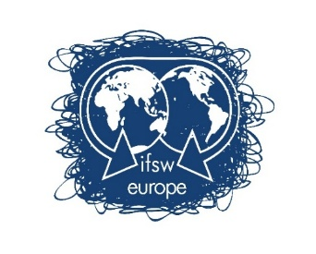
IFSW Europe Report 2025 - 2026

31 Countries and 33 Associations are currently full members at Global and European levels 2026

Armenia | Austria  - younion  -OBDS | Azerbaijan | Croatia | Czechia
Denmark | Finland | France | Georgia | Germany
Greece | Hungary | Iceland | Ireland | Israel
Italy | Belgium | Malta | Netherlands | Norway
Poland | Portugal – completing global standing | Romania  -ASproAS  -CNASR | Spain | Sweden
Switzerland | Türkiye | United Kingdom | Bulgaria | Moldova
Cyprus

There are fifty nations in the European Region, 46 of which have social work associations or similar bodies. In 2026 33 associations from 31 countries have been paid members at both global and regional level. In 2026 we welcomed back Moldova and Belgium and we are in active discussions with seven other countries about joining/rejoining.

Our high-level aims are in our 2025-27 strategy and workplan for the past year:

- Help to build stronger member associations
- Influence European and national social work associations’ policies
- Promote Social Work Knowledge, Practices and Identity
- Support social workers working conditions and wellbeing (New* proposals for 2026/7)
- Advocate for European social work within European and Global bodies
- Lobbying and campaigning
- Improving internal and external communications
- Securing our finances and growth
- Delivering the next IFSW Europe Conference
- Planning for the future and enabling involvement of next generation of social workers

The Context of European Social Work 2025/26 and implications for IFSW Europe

This has been a turbulent few years for Europe – politically, socially, economically, environmentally and militarily. The invasion of Ukraine by Russia and the growth of nationalistic, repressive and authoritarian governments in many parts of Europe have driven uncertainty, fear and division in many of communities where social workers practice. The impact of climate change is being felt increasingly in our communities and the cost-of-living crisis has hit many citizens hard. Poverty is rife and treatment of migrants has become less humane.

The impact of the rise of right-wing political populism is exemplified in the weaponisation of migration, LGBTQi, gender, religion and ethnicity in xenophobic discourse, with reported rises in hate crime and increased repression on civil society organisations (see e.g. report from Council of Europe on shrinking civic space https://shorturl.at/Z8CCU), aided by rising disinformation and online hostility at national and international levels.

These trends have presented new challenges for social work practice, values and ethics in many parts of the region. In this context, the expertise, resilience, connections and solidarity of IFSW Europe is ever more vital. Social workers across the world stand up for inclusive, participative democracy and social rights. In IFSW Europe we do this through representation within key intergovernmental and independent European institutions and bodies, through supporting specific professional issues at national level and through policy and practice statements.

The role of social workers in emergencies and disasters has come more to the fore across Europe in this context, as has the role of social workers as human rights defenders, eco-social and anti-poverty activists, champions of migrant rights and antiracism, and skilled practitioners in the digital and AI age. As a region we must ensure we are sharing our knowledge, expertise and mutual support in the face of these emerging priorities, and attending to the wellbeing and working condition rights of social workers ourselves.

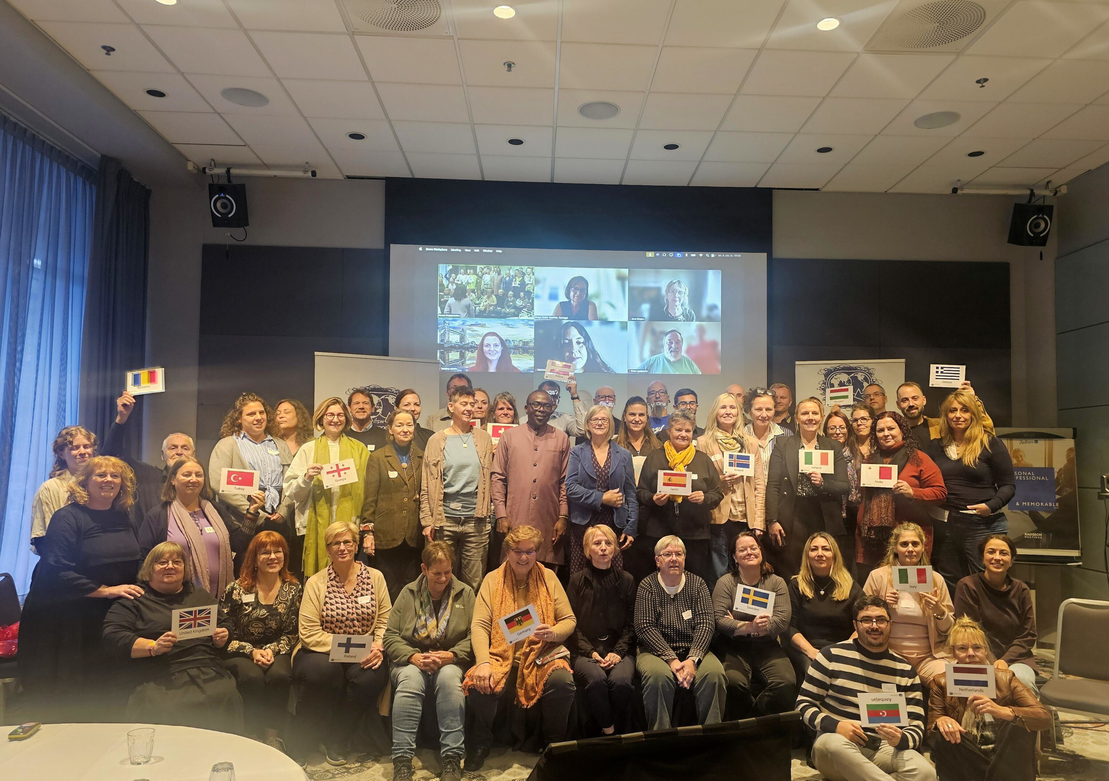
Delegates Meeting Attendees – Oslo, October 2025

Our Elected Leadership 2025-2026

The IFSW Europe elected Executive 2025-2026

- Dr Ruth Allen, UK: President 2024-2028
- Andreas Kikvik, Norway: Vice President 2024 – General Meeting in Nairobi
- Enric Torras, Austria, Executive Committee member – 2025-2027
- Susanne Both, Denmark: Executive Committee member – 2024-2026
- Nikos Zervas, Greece: Executive Committee member and representative of Hellenic Association planning the 2027 regional conference in Athens, Greece – Dec. 2025-2026
- Kristine Evertz, Netherlands, stood down as full committee member for personal reasons and continues as First Deputy Executive – Dec. 2025-2026
- Paola Pontarollo, Italy, Second Deputy Executive – 2025-2026
- Brian Auslander, Israel, Treasurer

- Jill Childs, UK, Honorary Secretary: Appointed 2024

The Executive meets online every six weeks and meets in person once per year in addition to meeting in the annual Delegates’ Meeting of member organisations for our constitutional meeting. The Executive works as a team, shares tasks and provides support to our members. Information about each Executive member is on the IFSW Europe Team webpage.

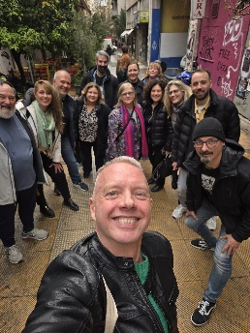
Informal picture of IFSW Europe Executive with colleagues from the Hellenic Association in Athens, Greece March 2026

Update on IFSW Europe Legal Body Status

IFSW Europe is a legal entity in its own right with its own constitution under German law, as well as being a regional part of IFSW Global. This year we completed another hurdle in the German courts and have now completed all necessary stages. This means we will soon be setting up our own banking arrangements rather than working through the German Association. Thanks to Herbert Paulischin, Gabriele Stark-Angermeier and Brian Auslander for overseeing this progress.

Supporting global governance improvements

Throughout 2025/26 the Europe President, Ruth Allen, Vice President Andreas Kikvik, and our member from Denmark, Birthe Povlsen, worked with IFSW Global colleagues to progress the IFSW ‘Good Governance’ review. This was intended to deliver on IFSW Europe’s motion at the 2024 General Meeting in Panama where Europe called for improved transparency and clearer processes in IFSW Global operations.

A report on the good governance review came to the 2026 General Meeting in Nairobi. While progress has been made, considerable development is still needed in governance and other operational processes at global levels. After the Nairobi meeting, the global Executive set transformation priorities for the next two years. Completing the good governance improvements is a top-level priority.

Details on IFSW global progress and next steps will be reported by the IFSW Secretary General in the Utrecht Delegates Meeting.

The Voice of Social Work: Representation in European and Global Institutions

IFSW Europe elect/selects and supports individual Representatives to work within international organisations to advocate for social work, IFSW Europe and our values. They advocate for social work, for the people we work with and for our values in high level regional bodies. Each representative sends a report to the Delegates’ Meeting.

The Representatives group has grown over the past two years with the inclusion of the Regional Commissioners from global commissions, the New Social Workers Network and a new
Representative for Romani and Traveller issues within the Council of Europe. Representatives meet online at least four times a year to share progress. In 2026, we appointed. Thanks to John Brennan (past European Vice-President – Ireland) who continues to Chair the Representative meetings.

Representatives to European Institutions 2024-2026

- Fundamental Rights Agency https://fra.europa.eu/en – Enric Torras, Austria
- Social Platform https://www.socialplatform.org/ – John Brennan, Ireland
Support team: Irem Cosanu Yalazan, Türkiye
- European Anti-Poverty Network https://www.eapn.eu/ – Birthe Povlsen, Denmark
- Conference of International NGOs, Council of Europe https://www.coe.int/en/web/ingo – Ruth Allen
  - Support team: Theresa Hoffman, Germany and Renuka Ramaswamy, UK from NSWN
- Eurochild https://eurochild.org/ – Anna Deneher, Ireland
- Romani and Traveller rights committee of Council of Europe (ADI-ROM) https://www.coe.int/en/web/roma-and-travellers – Alison Hulmes, UK

Representatives in Global IFSW Commissions

IFSW Europe has been working with the IFSW Global Commissioners and Global Secretariat to implement the new Commissions policy. The regional commissioners and support teams are now linked it with regional as well as global networking opportunities including Representatives meetings. As of June 2026 the commission representatives are :

- UN (Geneva office https://www.ungeneva.org/en/about/who-we-are) Regional Commission Team-
  - IFSW Europe Representative in Geneva office - Sybille Mani, Switzerland
  - Geneva NGO Committee on Ageing (and related) - Gerry Nosowska, UK
  - WHO link - Akudo Amadiegwu, UK
  - World Social Work Day lead – Swetha Raodhananka, Switzerland
  - UN Human Rights Office and International Labour Organisation – Annalisa Baruffi, Switzerland, now UK
- Education Regional Commissioner – Marcin Boryczko, Poland
  - Support Team – Janet Walker, UK
- Ethics Regional Commissioner – Gabriele Stark-Angermeier, Germany
  - Support team: Graca Andre Queiros, Portugal
- Indigenous Regional Commissioner – Margaretha Uttjek, Sweden

Supporting the global commissions at regional level:

- IFSW Europe funded the new regional UN team to meet in Geneva in May 2026 to build their relationships and plan their work.
- IFSW Europe also funded the Regional Indigenous commissioner, Margaret Uttjek, to attend the UN Permanent Forum on Indigenous Issues (UNPFII) in April 2026, supporting the global commissioner, the only social work representatives in this vital global forum.

Europe Regional Conference – Oslo and Alta, Norway, 6-8 October 2025
Bridging Communities: Building Sustainable Futures.

Our 2025 European conferences in Oslo and Alta, Norway were hugely successful. A full write up on the IFSW website here https://shorturl.at/0JdPj . Both conferences were organized by Fellesorganisasjonen (FO), the Norwegian Union of Social Educators and Social Workers, IFSW Europe represented by Vice President and senior policy officer in FO, Andreas Kikvik.

Over six hundred social workers, educators, and researchers from across Europe and beyond gathered together in Oslo, and seventy made the journey to the far north of Norway for the second conference focused on the indigenous Sami community.

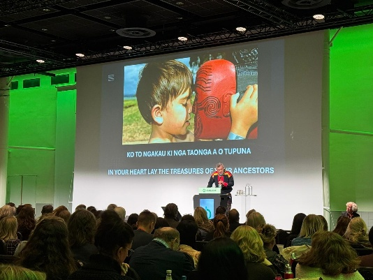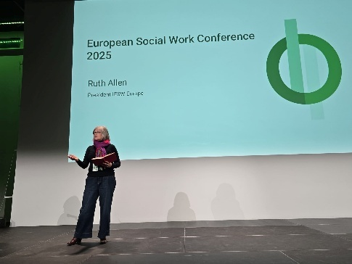

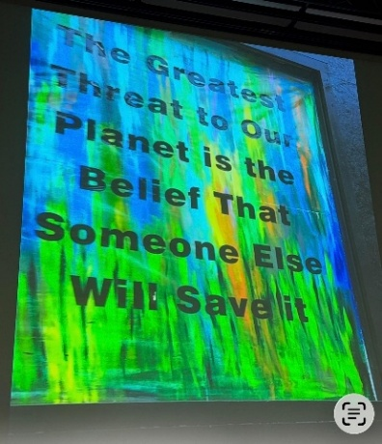
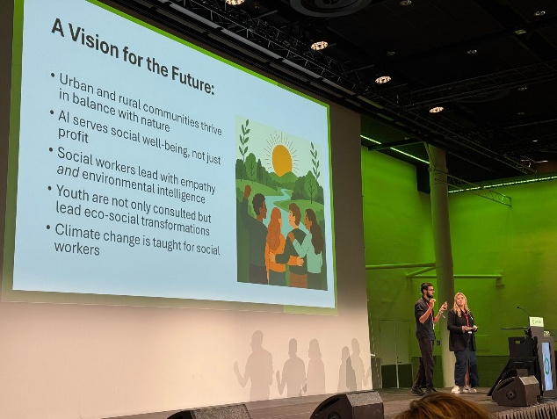

The conference brought together social workers (the largest ever in Norway!) activists, academics, commentators, authors, politicians and artists of different disciplines centred on themes of Green Social Work, Climate and Environmental Change, the UN’s Sustainability Goals, and Indigenous Perspectives. Over three days, through talks, cultural moments, political engagement, workshops, field visits and creative side events, we explored the deep interconnections between people, society, nature and our profession.

From discussions on eco-social democracy and de-colonising social work, to reflections on climate adaptation, disaster response, education and the future of work for a sustainable future, the sessions reaffirmed that the profession is and must be at the heart of the global transformation challenges we all face - working for social justice, the wellbeing of people and nature, and hopeful futures for all.

‘Post-conference’ in Alta, Northern Norway

Around 70 people also attended the two day ‘post-conference’ focused on and led by social workers, activists and academics from the Indigenous Sami community in Alta, Sápmi in the far north of Norway. We learnt about the history of social work in Sapmi, about the activism for Sami rights and how social workers have been part of this, and about the environmental challenges for Sami communities across the whole of northern Scandinavia.
We were also joined for an inspiring talk by global Indigenous Commissioner for IFSW, Hilary Weaver.

This moving, illuminating event deepened our knowledge and appreciation of the challenges for indigenous people in Europe and beyond. It also brought home the vital value of indigenous knowledge, wisdom and traditional ways from which all can learn, and the key role of social workers in supporting and advocating for indigenous rights.

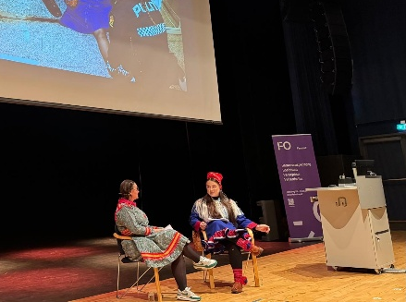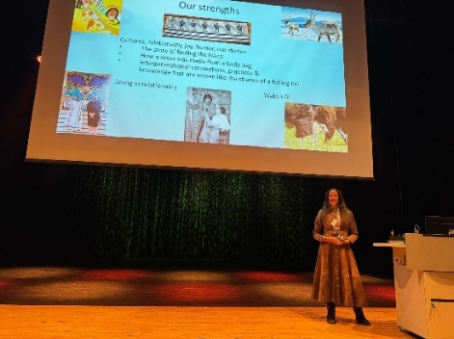

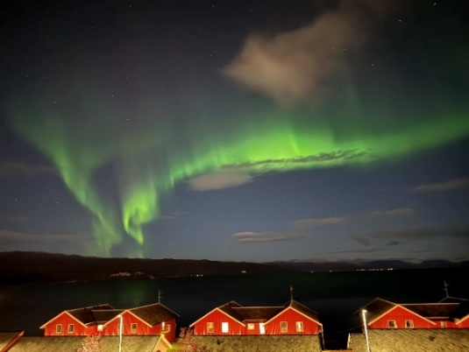

Top L-R: Sami social workers and activists; Hilary Weaver, IFSW Global Indigenous
Commissioner

Together, these events created a powerful space for reflection, learning, and solidarity, highlighting how social work is central to building a sustainable, caring, and inclusive future for all at national and international levels.

European Conference October 2027 –
Co-building Inclusive Social Trust
The Megaron, Athens, Greece

The 2027 European conference will be in Athens, Greece in October 2027. The initial concepts have been developed. The venue will be the Athens Concert Hall ( the Megaron) a beautiful, landmark venue right in the centre of Athens, next to a park and the Metro station.

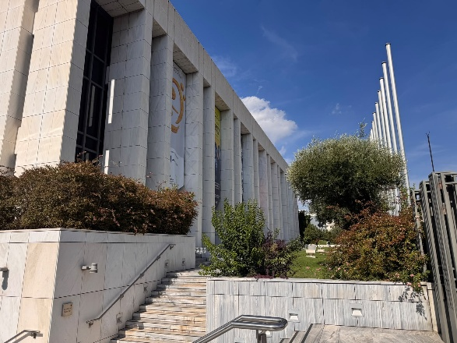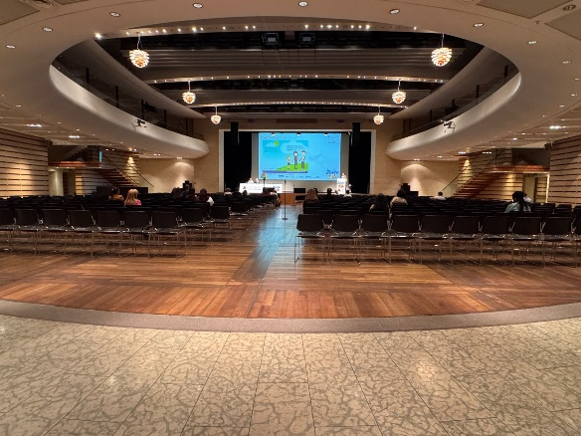

The conference company has been appointed and initial graphics, marketing, timelines and information about bookings and opportunities to present will be available during the 2026 Delegates’ Meeting.

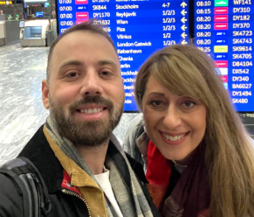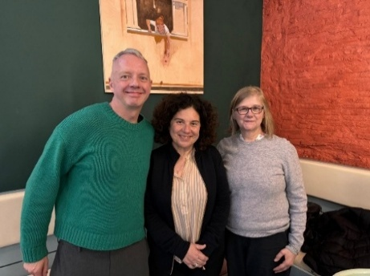
Conference lead organisers IFSW E Vice President Andreas Kikvik,
from the Hellenic Association Hellenic Association President
Nikos Zervas and Olga Verikaki Triantafyllia ('Fyllio') Athanasiou and
IFSW E President Ruth Allen

IFSW Global Centenary Conference July 2028
Solidarité: Transitioning to Inclusive and Collective Futures
Université Cité, Paris, France
The global conference will come to Paris in 2028 to celebrate the hundredth anniversary of the first International Conference of Social Work in 1928 which brought together people involved in social welfare, social work education and practice from across the world, laying foundations for the contemporary tripartite structure of IFSW, IASSW and ICSW leading the profession across the world.
IFSW Europe will be supporting and promoting the conference, working with our French member, ANAS, and the local organising organisation UNAFORIS, to ensure this event is a regional and global success.

Developing the profession and IFSW: Projects 2025-2026

Project: Eco-Social Work: Next Steps

Launched in 2021, the eco-social project, led by Josien Hofs (Netherlands) presented its final report in the Delegates Meeting in Lisbon October 2025. Activities of the project included:
- Webinars in 2021 and 2022.
- Presentations and workshops on conferences in Zagreb (2021 online), IFSW-E Prague (2023), BASW conference (2024), Belgian-Dutch SW conference Rotterdam (2024), EASSW Salzburg (2025)
- Participation at Brussels EU conference European Employment & Social Rights Forum (Brussels, November 2023)
- Presentations and discussion at the IFSW-E Delegates Meeting in Berlin, Prague and Lisbon.
- Two-day eco-social conference in Rotterdam (2024) with Inholland University
- Preparation in cooperation with Dr Richard de Brabander, with representatives from Belgium, Poland and Sweden, of a symposium in the Oslo regional conference 2025
- Preparation for a workshop in Oslo 2025
The Delegates Meeting 2025 thanked Josien for her leadership, which has significantly raised the profile of eco-social work including providing the theme of the 2025 Regional conference.

Delegates agreed that the focus on eco-social work will continue and endorsed an ongoing steering/interest group, actions to promote mainstreaming of eco-social practices within holistic social work, and pursuit of further funded projects in this vital field.

The ongoing eco-social project is now under more structured development through collaboration with Inholland University. A workshop at the Utrecht DM will be the next steps in building further tangible resources for social workers across Europe, and the basis of bids for funding to complete this work.

Project: Strengthening Social Work Across Europe through IFSW (SSWAE)

Funded by IFSW global, this project aims to develop IFSW Europe’s responsiveness and consistency in supporting members in ways that recognise their diversity of strengths, needs and priorities; their differential access to power and resources to be involved in IFSW; the need for timely response to associations when social workers are under duress (e.g. through conflict, disasters or oppression); taking account of historic differences, past and current colonialism, and other power and resource imbalances between different parts of Europe.

The project recognises the need for conscious attention to difference and inequality in membership whilst ensuring IFSW Europe develops further as a unifying professional community with common purpose. In the IFSW conference in Nairobi 2026 , IFSW Europe led a workshop concerning the SSWAE themes, co-designed and delivered with colleagues from four regions in IFSW.

A summary report from the Nairobi workshop is available as on the DM webpage.

Project: Responsive Social Services: Funded by EU

From 2023 - 2026, IFSW Europe has been an active partner in developing and delivering the multi-country, three-year EU Horizon Responsive Project. You can read more on the dedicated website here https://responsive-europe.eu/

While it is EU funded, the learning and innovation examples from the project are widely relevant and cover universal challenges and opportunities for social workers. The Responsive project aims to enhance the responsiveness of Europe’s social services to input and feedback from diverse citizens and to promote social services as a field for promotion of democracy and agency for citizens rather than as a place only of ‘receiving’ help and care.

IFSW Europe’s specific roles - in addition to providing ongoing perspectives from a social work grassroots/fieldwork and policy perspective – included designing and leading a large social work survey, dissemination activities, contributing to writing final reports and resources, coordinating and contributing to a dissemination event in the European parliament in Brussels and organising webinars. Members of the IFSW Executive ran a workshop on the final dissemination conference in Lisbon in January 2026 and presented with the New Social Workers Network at the European Parliament event in February 2026.

A social worker practice guide based on the Responsive project is in development.

Project: COCOSO – Co-construction in the field of social welfare: and industrial doctoral programme: Funded by EU

COCOSO is a doctoral programme for fifteen fully funded students, dedicated to promoting participation and co-construction as a core dimension of democracy and innovation in social welfare. COCOSO is designed to address the pressing demand for meaningful and efficient participation of citizens involved in social services and policies: people with experience of using social services, practitioners, decision and policymakers.

IFSW has a role in supporting and delivering training, support and advice throughout the life of the project.

Project: Social workers in war, conflict zones and disasters

Throughout 2024-25, the war in Ukraine has continued to rage and the risk of wider military conflict in Europe has felt closer than for decades. We finished and reported on our IFSW member funded projects in Ukraine which is described here https://socialwork-ukraine.eu We will continue to learn a huge amount from those innovations and the ongoing work they have catalysed in Ukraine. Social workers continue to work with other forms of disasters such as the ongoing work to support victims of the 2023 earthquakes in south westers Türkiye and the role of social workers in prevention and response to wildfires in Spain.

The importance of social workers and other professionals having skills in responding to disasters and conflict is a focus for the European Union at high policy level as well as in national policies. We have been represented within EU work on a publication on the role of social workers in disasters and emergencies by Ana Radulescu. Our workplan includes continuing learning and sharing of knowledge in this field, along with partners and allies.

IFSW Europe is now building relationships with networks of practitioners, academics and authors working in this field with a view to hosting an umbrella community of practice (or similar) with them.

Future projects and funding

IFSW Europe will be focusing strongly on funded projects and other financing opportunities during 2026/27. This is essential to keep our income and activity levels in the next year and beyond, and to raise the status of IFSW E. Our developing partnership with the European Association of Schools of Socia Work is intended to be a helpful basis to develop joint bids with universities.

Other key activities in the workplan are:
- Establishing an advisory expert group on bid writing and fundraising from within IFSW E and externally
- Bidding activities in development: eco-social pre-bid activities and consortium building; working conditions pre-bid with a Greek and UK University; domestic violence bid with a Greek-led European consortium
- Philanthropy options
- Raising revenue from the annual conference
- Raising revenue from other CPD activities at European and/or national levels

Members will have the chance to give their views on how we prepare for more funded projects and fundraising at the Utrecht DM.

The New Social Workers Network

The New Social Workers Project was conceived in 2019, as part of the ‘A Social Europe is Possible!’ project. This led to a group of new and young social workers forming and undertaking research to understand and learn from the experiences of students and newly qualified social workers across diverse nations. A growing group of new and young social workers have now created momentum and are reaching to more associations and inviting new social workers from across Europe to get involved.

Report from the New Social Worker Network steering group

Since becoming a formal Network within IFSW Europe, the NSWN has continued to strengthen its role as a developing platform for participation, collaboration, and leadership development amongst early-career social workers. The Network now includes approximately seventy members from 15 countries across Europe, showing the potential to increase collaboration and engagement from students and practitioners within their first five years of practice across Europe.

Over the past year, the NSWN has focused on implementing its 2025–2026 Action Plan across six priority areas: membership, funding, events, communications, policy paper development, and engagement with the Federation. Membership recruitment is still a key success, supported by active outreach through member organisations, social media channels, and promotional materials. A webinar hosted in Portugal in March 2026 attracted over 100 participants and resulted in 21 new members joining the Network, with more webinars being planned.

The Network has also increased its visibility through participation in conferences, webinars, and international forums. A proposal for a presentation/workshop has been submitted to the Council of Europe's World Forum for Democracy and European Social Network Conference, while members continue to promote the work of IFSW Europe and the Network through national and regional events. Communications have expanded through utilising IFSW Europe social media platforms and the development of regular content, including blogs and online engagement activities. A major area of progress has been the development of a co-produced policy paper on intergenerational working within social work. The paper has been drafted and is currently being refined through consultation with members and representatives across the Federation for discussion and adoption in the European Delegates’ Meeting in the Netherlands in October.

This work reflects the Network’s commitment to strengthening collaboration between generations of social workers and supporting sustainable professional development.
Importantly, the formal integration of the NSWN into the IFSW Europe work programme, supported by an agreed action plan and budget, ensures that the perspectives of new social workers are embedded within the Federation’s structures and future development.

Network members are also increasingly engaging in representative and support roles across the Federation, including involvement in representing IFSW Europe in the Council of Europe’s Conference of International NGOs (CINGO) activities, demonstrating a sustained commitment to leadership and professional participation. The Network continues to contribute to building the next generation of social work leaders, human rights advocates, and democratic innovators across Europe through its links with many projects in Europe and its openness to dialogue with colleagues globally.

A full report from the NSWN is also available on the DM webpage.

Contact the New Social Workers via newsocialworkers@ifsw.org

World Social Work Day 2026: Uniting a Divided Society

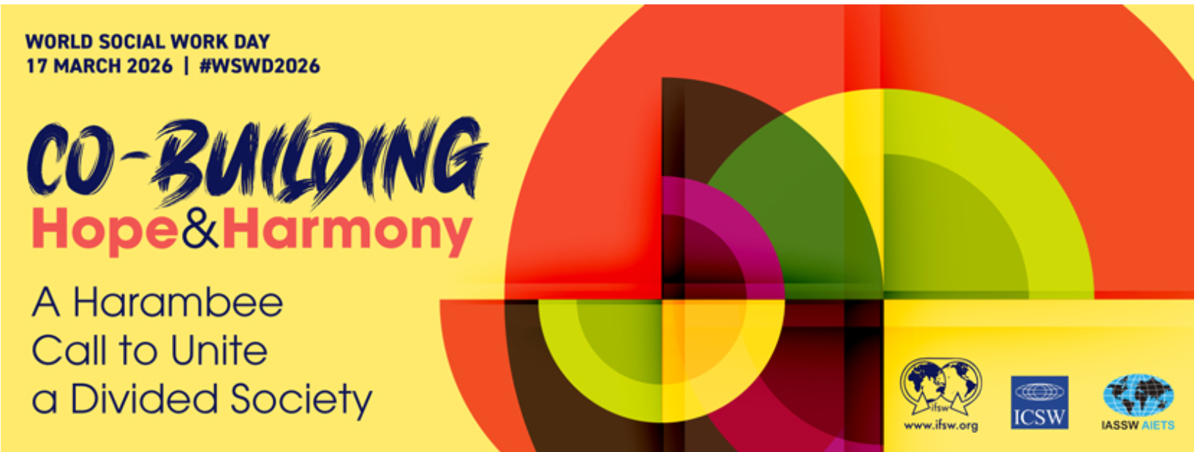

Webinar 11th March 2025: Making Social Work Responsive and Inclusive Across Europe: Transformative messages and reflections from the 'Responsive' Research and Innovation Project . This explored the key messages from the research and introduced key ideas that are forming part of a practice resource for social workers. This research included a focus on how social services can drive inclusion, equity and democracy within communities, work co-creatively with citizens and meet diverse needs and strengths through greater responsiveness.

Communication with and between members

In 2025, we started a regular newsletter for members, distributed through emails and provided in non-confidential form) on the IFSW website. We received feedback on the need for better communications from a member survey and from an exercise at the Delegates Meeting. In 2026 /27 we will implement a much effective ways to keep in touch with our members and prospective members, enable members to communications with each other. This will be discussed at the 2026 DM.

We are also using three social media platforms:
Facebook - https://www.facebook.com/EuropeIFSW/
LinkedIn - www.linkedin.com/in/ifsw-europe-623415396
Instagram - https://www.instagram.com/ifsweurope/

National member conferences 2024/25

Congratulations to all members who have organised national conferences for WSWD and for other significant reasons. President Ruth Allen provided video messages or live contributions online from IFSW Europe for events in Malta, Latvia, Norway, Portugal, Türkiye, Bulgaria, Moldova and Czechia. Here are three example reports from Türkiye, Czechia and Moldova.

The Turkey Social Services Congress, Ankara. November 15-16, 2025

The national Association of Social Workers (SHUDER) organized the 9th Social Services Congress with the theme of "Social Services in the Spiral of Hope, Shame and Despair" on, in Ankara and provided a full write up which is available here on the IFSW website https://www.ifsw.org/social-services-in-the-spiral-of-hope-shame-and-despair-was-discussed-at-the-9th-national-social-services-congress-in-turkiye/

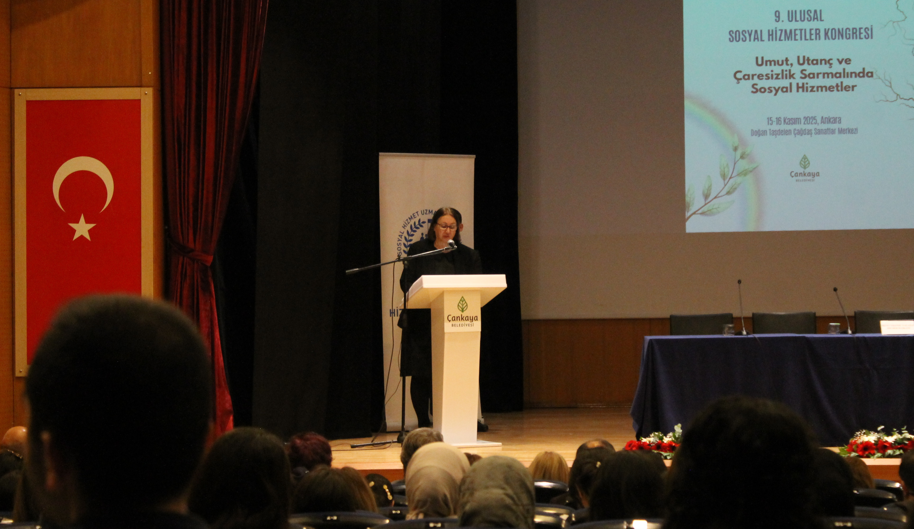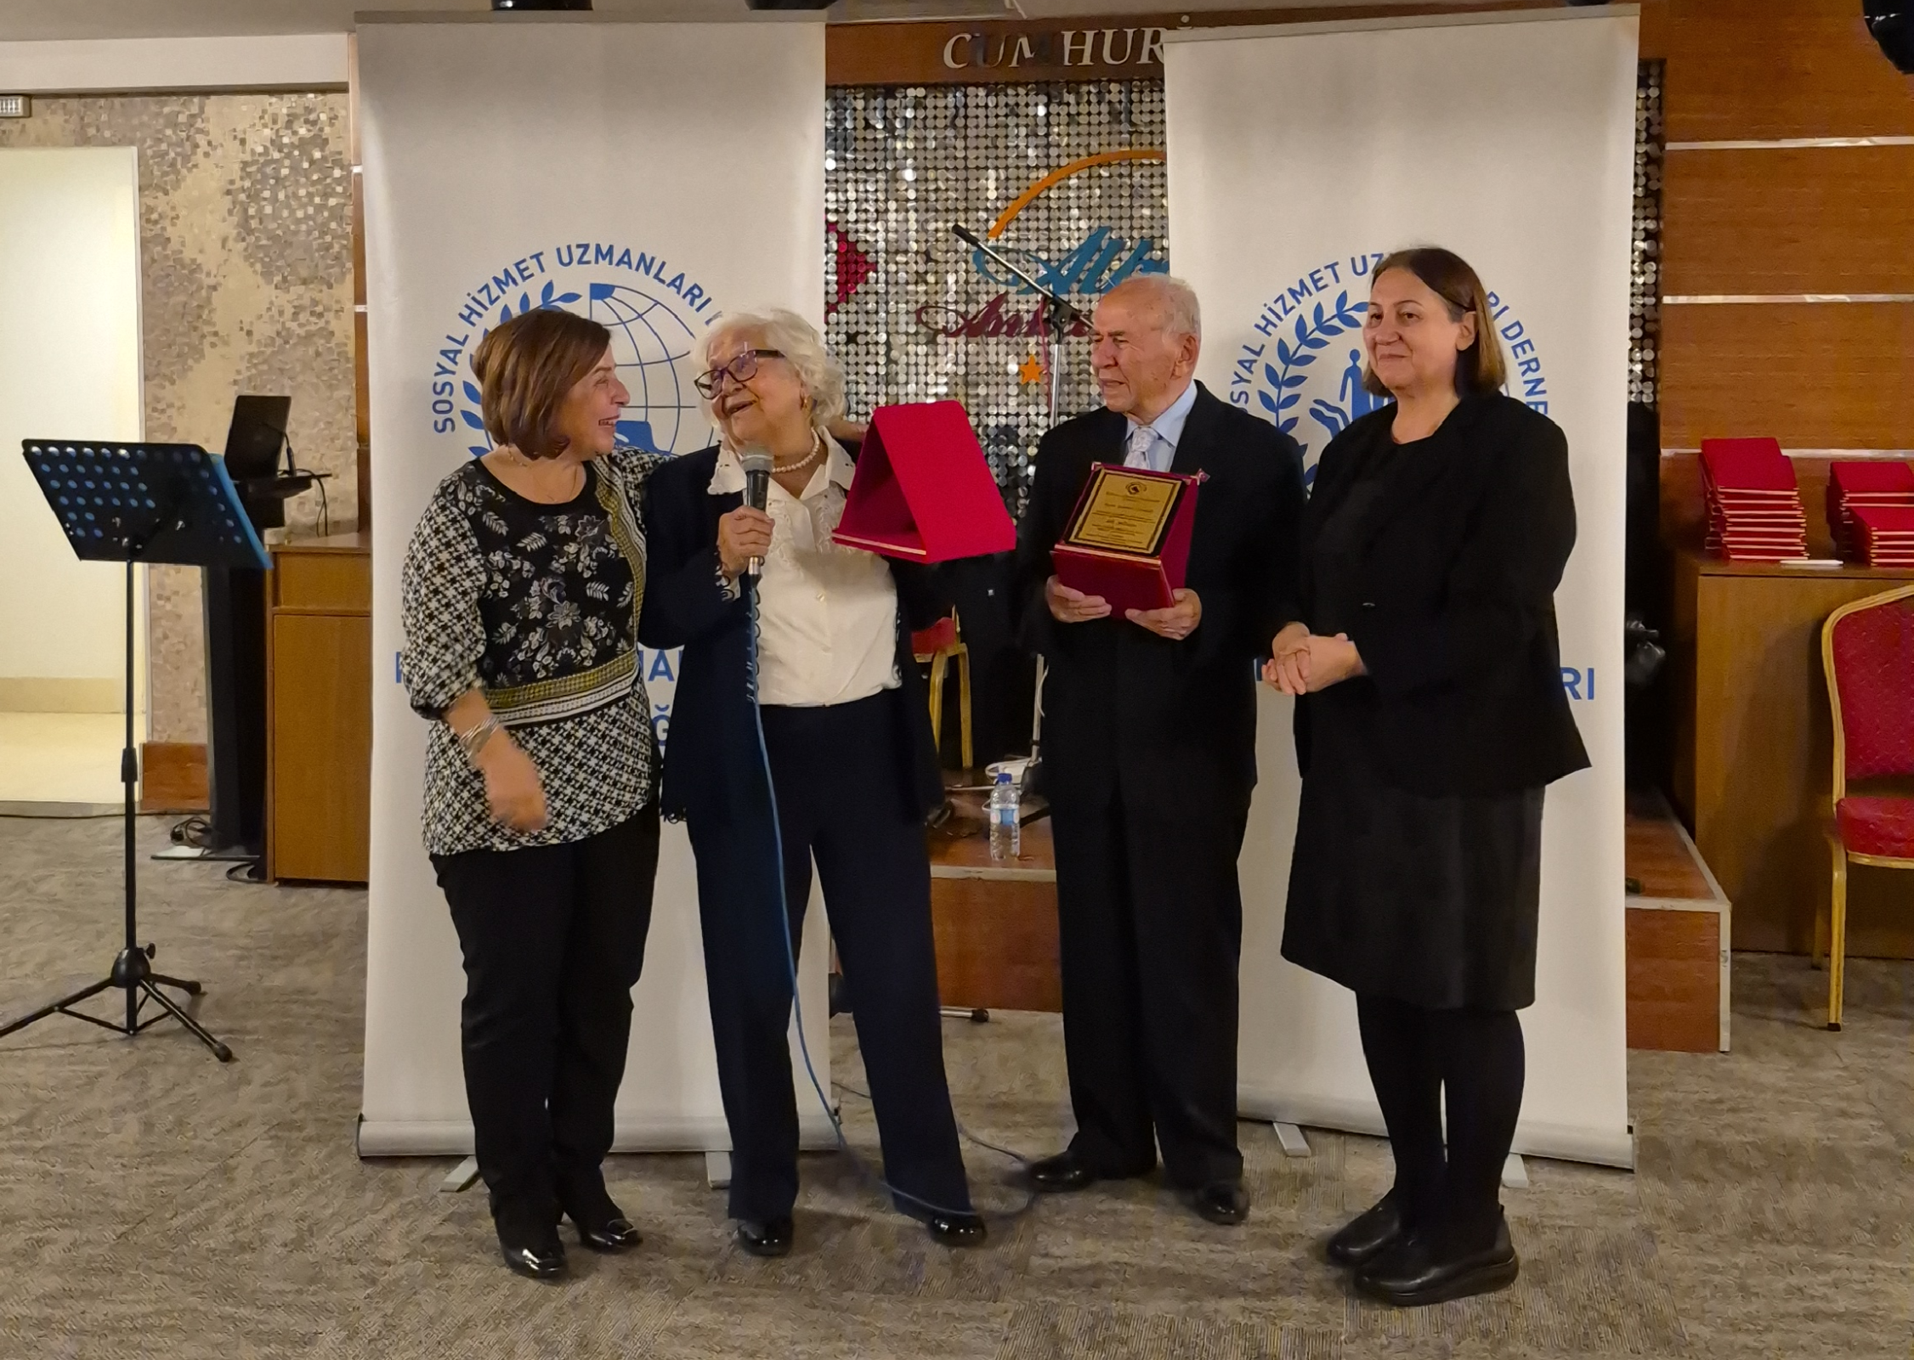

Left: SHUDER President Irem Cosanu Yalazan address the Congress. Right: President Irem (right) joins colleagues celebrating 60 years since graduation

The Czechia 100th Anniversary Conference, Prague. December 2025

President Ruth Allen spoke in person at the Czech Association of Social Workers celebration of 100 years of social work, in December 2026. At a time of new political and professional challenges including the diversity of social work bodies in the country, the conference explored learning from the 100-year history of social work in Czechia under liberal and repressive regimes; the challenges of improving working conditions and unifying advocacy for social workers across the country. The value of international cooperation and shared learning through IFSW was also discussed.

Left: IFSW Europe President Dr Ruth Allen addresses social workers in Prague, Czechia
Right: Pavel Pankava and Deputy Chair Petr Zavel meeting with Ruth before the conference to discuss the issues for Czechia and the role of IFSW in supporting associations to thrive.

The Moldovan Congress social work and community wellbeing – Moldova May 2026

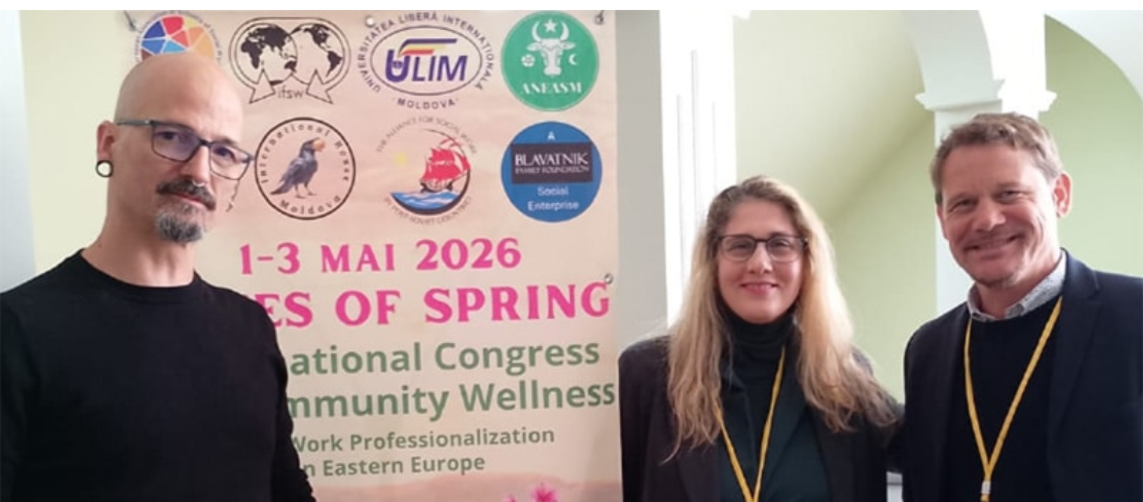
Enric Torras, Austria - IFSW Europe Executive ; Paola Pontarello, Italy – IFSW Europe Deputy Executive; Pascal Rudin, IFSW Global Interim Secretary General.

Representatives from IFSW Europe and IFSW Global participated in the Seventh International Congress on Community Wellness held in Chișinău, Moldova, from 30 April to 3 May 2026. The congress brought together more than 100 participants from 13 countries to explore community wellbeing, social solidarity, and innovative approaches to social work in times of growing uncertainty and fragmentation.

The IFSW delegation included Ruth Allen, President of IFSW E (online) Enric Torras, Paola Pontarollo, and Pascal Rudin. Their participation reflected IFSW’s ongoing commitment to strengthening professional dialogue, regional cooperation, and community-led social development across Europe and beyond.

Attica Region Conference on Child Protection, September 2026

In September 2026, the Attica Regional Department of the Hellenic Association of Social Workers in Greece (HASW), the statutory professional body representing social workers in Greece, organised a Child Protection Conference in Athens, bringing together around 500 professionals, social workers. The conference called for immediate reform of the child protection system and identified a set of concrete priorities: strengthening family-based care and foster care to support children and their biological families and prevent unnecessary separation; ensuring universal and free access to social care, health and mental health services; investing in early intervention and prevention before families reach crisis; strengthening and empowering parents; reinforcing community-based social services, particularly within local government; implementing the provisions of Law 2447/1996 concerning fully staffed social services within the courts; establishing an integrated framework of cooperation between child protection, health, mental health, education and justice services; and advancing deinstitutionalisation.

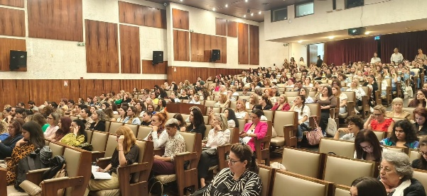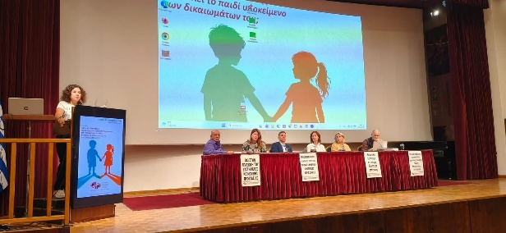

A central outcome of the conference was the commitment to place children’s rights and participation at the heart of the system. Children should be informed, heard and involved in decisions affecting their lives, according to their age and maturity. The conference emphasised that child protection should not begin with institutional placement, but with support for children and families within their communities. The message from the approximately 500 participating professionals was clear: Greece needs a coordinated, preventive and rights-based child protection system, with meaningful and immediate reform.

