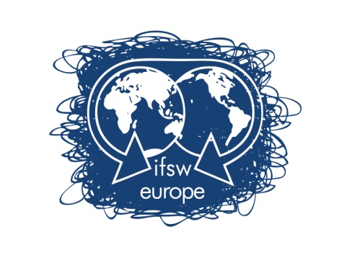

**Treasurer’s Report 2024-2025**

Item 8.1 (Amended)

**NOTE: The draft budget for 2025 – 2026 is now presented in a separate paper ‘Amended draft budget’.**

Our income and expenses are divided into budget lines for operating expenses and projects. The annual operating expenditures are funded mainly by our membership fees and any profits from the regional conferences; the projects have received funding from varied sources which is only used for the specific project. Some funding sources have included IFSW global, donations, the EU and NGO funders. We intend to develop funding sources outside our membership fees in the future.

In 2024 our operating expenditures totaled €28,947.71 against a budget of €35,983.00.

We began 2024 with a balance of €280,426.93and ended the year with a balance of €155,522.14. Our total income was € 91,451.29 and we had expenses of € 206,445.01.

The reason for this was we continued to spend money in 2024 that had been raised in earlier years for the projects in Ukraine. All money for the Ukraine projects has now been spent and accounted for in our audit.

Regarding 2025, the beginning balance was €155,522.14. As of this writing, we had new income of €41,344.60 and expenses of €49,131.66. The bank balance as of current date is €147,783.86. Most members that we expected to pay have now paid their 2025 membership fees and we will reach our budgeted goal of €30,000. We will be looking to expand our community of engaged associations and our paying membership in 2026.

Other income that we expect to receive are surplus from the Oslo conference (which we share with FO) and a grant of €10,000 approved by IFSW Global for our ‘Strengthening Social Work and IFSW Europe’ project (see the papers for the agreed bid and the agenda for information on a workshop in the DM).

We are expecting significant additional expenses before the end of the year. Therefore, the 2026 budget includes an estimated starting balance of €100,000. The executive is proposing a budget for operating expenses of €40,500 for 2026.

Our operating expenses are rising each year and fees are staying basically the same. Theoretically, our budget should not exceed our income from membership fees and conference profits. These are the only non-restricted income we receive. Not all conferences are profitable, so it is impossible to count on this as a sure source. The issue of raising the fees has been discussed at previous delegates’ meetings and voted down leaving the fees the same since their inception (which was before my time in IFSW). Since the fees are based on the number of members in an organization, the only way for this income to increase is where accurate rises in membership are reported to IFSW and if more associations become paying members.

Each Delegates Meeting needs to decide on the fee for the coming year and a vote will be held on this.

Submitted by:

Brian Auslander, Treasurer