Nomination of candidates
for IFSW European Regional Executive Committee

NOMINATION FORM

Name of candidate Dr Ruth Allen………………………………………………………
Country …… United Kingdom………………………………
Address …… (work) 37 Waterloo Street, Birmingham, B2 5PP UK
…………………………………………………………
E-mail address (work) ruth.allen@basw.co.uk
(personal) ruthallenonline@gmail.com ……………
Nominating organisation …British Association of Social Workers ………………………………………………………
Positions held in nominating organisation Chief Executive
………………………………………………BASW member…
…………………………………………………………
…………………………………………………………
Candidate
I agree to be nominated for the post of Executive Committee Member in IFSW Europe e.V. and confirm that I am a member in good standing of the IFSW member organisation which is
nominating me

Signature 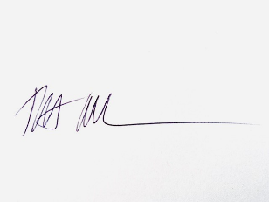

15/05/2023…………………

Nominating organisation

I hereby nominate the above individual for the post of Executive Committee Member and confirm s/he is a member in good standing of this organisation. I am authorised to make this nomination on behalf of the organisation.
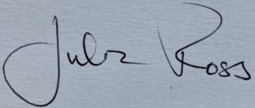

Signature Julia Ross ………………………………
Position in IFSW member organisation Chair of BASW UK
Organisation British Association of Social Workers………
Date 15 05 2023

Please also send a CV for the candidate and a short election statement [maximum 300 words].
This should be sent with this nomination form to Teodora Dobre [Honorary Secretary of IFSW
Europe]: europe@ifsw.org

