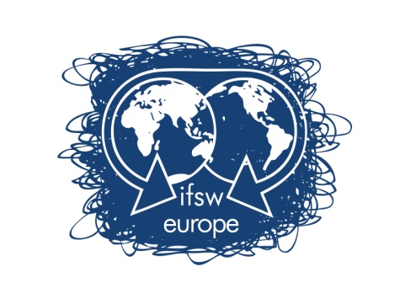 | Work programme 2022-2023

This work programme is presented within the framework of The Global Agenda of IFSW under the following broad subheadings:
- Visibility and Voice
- Membership development
- Services for members.

IFSW commits to work wherever possible with people who use social work services to develop and implement its activities.

The priorities for 2022-2023:

1. COMMUNICATION
OBJECTIVES
  - Increase Online Visibility
Knowledge sharing – organise webinars and publish about the activities of our member organisation
  - Increase Internal Communications
Increase the contribution of member organization to the activity of IFSW Europe Representatives;
  - Increase communication with IFSW Europe partners
Ensure continuity between IFSW Representatives and our partners;

2. FINANCES
OBJECTIVES
2.1. Prepare applications for external funds and access external resources for specific activities;
2.2. Ensure efficient management of IFSW Europe finances;
2.3. To finalise the process to bring the IFSW Europe as a legal body in compliance with the German authorities.

3. MEMBERSHIP DEVELOPMENT
OBJECTIVES
3.1. Support member organizations to develop more active arrangements for mutual support and development, such as webinars for our members to facilitate sharing and learning.

4. IFSW EUROPEAN CONFERENCE
OBJECTIVES
4.1. Provide the necessary support to members for organizing IFSW conferences;
4.1. Ensure the visibility of the IFSW European conferences.

5. IFSW Representatives
OBJECTIVES
5.1. Engage social workers in the work of IFSW Europe and to represent us in contact with our partners;
5.2. Ensure coordination between the IFSW Europe agenda and the activities of IFSW Europe representatives. To help achieve this aim, set up a facility via the Executive Committee for all Representatives to meet regularly to coordinate activities and plans.

6. NETWORKING AND LOBBYING
OBJECTIVES
6.1. Engage with EU network and institutions (including the EU Commission and Parliament), UN, Council of Europe and the other network in Europe to further the voice of social work.

7. THE SOCIAL WORK DAY 2023
OBJECTIVES
7.1. Create and promote all over Europe common key messages within the Global Agenda theme of 2023.

8. RELATIONS WITH IFSW GLOBAL
OBJECTIVES
  - Ensure IFSW Europe representation to the IFSW Global Commissions;
  - Contribute to the Global Agenda for Social Work and Social Development process.

9. POLICY DEVELOPMENT AND SOCIAL ACTIONS
OBJECTIVES
9.1. Develop policy statements that reflect the priorities of IFSW Europe member organisations;
9.2. Develop IFSW Europe documentation/information packs on the implementation of the European projects to support member organisations in any advocacy work at EU level;
9.3. Set up a consultation mechanism to define ‘social services’ from an IFSW Europe perspective. Definition to be brought to the next Delegates meeting for ratification;
9.4. Participate in the 2023 Poverty Watch Survey coordinated by EAPN.

10. ENSURE AN EFFICIENT MANAGEMENT OF THE PROJECTS
10.1. IFSW European Project (2018) – Social workers for transformational and sustainable social protection in Europe;
10.2. IFSW European Project (2020) – A Social Europe is possible! The new generation of social workers – FOLLOW-UP
10.3. IFSW European Project (2022)– Developing eco-wisdom – leave no one behind!
10.4 Increasing responsiveness to citizen voice in the social services across Europe.

11. NEW PRIORITIES TO TAKE FURTHER
10.1. Eco Social Work & Climate Change;
10.2. International Collaborative Social Work Learning.

IFSW Europe 2022

