

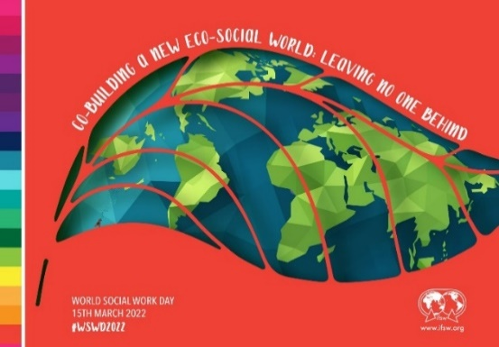

The theme **for World Social Work Day 2022** is `Co-building a New Eco-Social World: Leaving No One Behind.´

**To celebrate on the 15th March Newham Council’s Adult Social Care and Children’s Directorates** are jointly hosting a half-day session for social care practitioners. As part of the event we will be hosting speakers represented from a local, national and international level including Newham Council’s Chief Executive, the Chief Social Worker for England and keynote speaker: the Chair of BASW (IFSW member). In addition we will look forward to hearing from our very own frontline social workers and residents reflecting on this year’s theme.

**Social Work Objects**

We have asked our social workers and practitioners to take pictures of an object that represents any of the areas below and share their reflections/reasons for their photo:

Just ice?



* **Global community**
* **Shared values**
* **Climate change**
* **Sustainability**

All photo contributions will be collated and presented on the day and the best picture will win a sustainability prize!

*“I chose this picture because it symbolises melting glaciers – the effects of climate change caused by global warming and the implications for the future of our planet.* ***‘Just ice’*** *is a play on words evoking the importance of preserving* ***‘justice’*** *for oppressed communities across the planet as well as preserving the planet itself.”*

Berylin Moore, Principal Social Worker Adult Social Care, London Borough of Newham, UK.