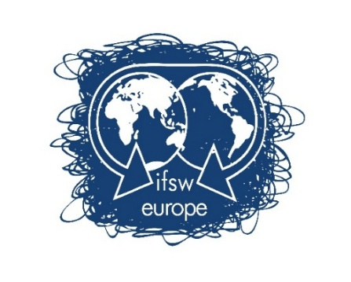
IFSW Europe News Briefing for Members – April 2026 (No. 5)
Dear Members
We are in Spring across Europe, a hopeful time of renewal - and it’s always great that we celebrate World Social Work Day (WSWD) in this season. Thanks to all of you for the celebrations that promoted the global theme and made social work so visible around WSWD.
You can read our WSWD (week!) blogs and all our regular news on the IFSW Europe pages of the website https://www.ifsw.org/regions/europe/ .
On WSWD itself , I was delighted to speak about international social work and its connection to domestic practice to diverse and passionate children and families social workers in a municipality just outside London, UK, and also to address the very interesting online conference of social workers in Bulgaria. Contrasting contexts, overlapping professional issues.
The WSWD Harambee message this year of hope and unity across divided societies is much needed in the face of national, regional and global division conflict.
This is a very troubled time in international relations and risks If something good can come from the divisions and wars we are seeing at national and international levels perhaps it is that they may inspire and energise us to come together even more effectively as an ethical, values driven and inclusive profession.
To keep up to date with all that IFSW Europe is up to, please go to the Europe web pages on https://IFSW.org website, and also follow us on the following social media accounts:
LinkedIn linkedin.com/in/ifsw-europe-623415396
Facebook page: https://www.facebook.com/EuropeIFSW
Instagram: https://www.instagram.com/ifsweurope/?hl=en

We are continuing to develop these and welcome your feedback too!
There is a lot to be proud of in social work across Europe. I hope you enjoy reading about some highlights and developing projects in this briefing.
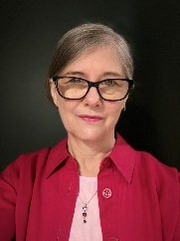
Dr Ruth Allen, IFSW
Europe President 2024-2028

HOLD THE DATES! TWO IMPORTANT MEETINGS FOR YOUR DIARIES

ONLINE SPRING MEETING OF EUROPEAN MEMBER ASSOCIATIONS
May 6 2026: 19:00 CET
This meeting is an opportunity for member association representatives to discuss achievements, priorities and opportunities at the mid-point between our Delegates’ Meetings.
Please send any agenda requests to europe@ifsw.org
This is a members meeting by invitation only. The joining zoom link will be sent to closer to the time.

THE 2026 DELEGATES MEETING
October 9 – 11 in Utrecht, Netherlands and online
A warm welcome to Utrecht from your 2026 hosts BPSW - the Dutch Association of Social Workers! A productive and innovative three days are being planned and we hope to see many of you there. Being together in person really helps us build out community.
Thanks to our Dutch colleagues who are working with the Executive to create a productive and enjoyable event.
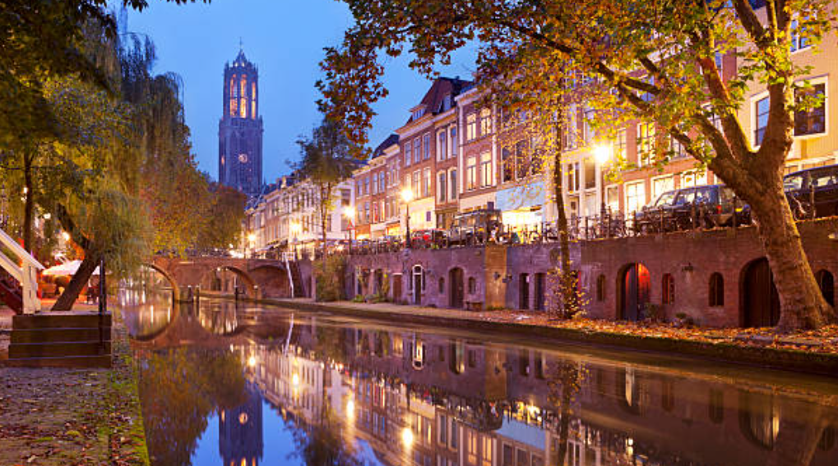
Practicalities
The meeting starts on Friday 9 October at 14:00 and ends on Sunday 11 October at 12:30 Central European Summer Time
Getting there
Utrecht can be reached easily and quickly by train from airports in Amsterdam (Schipol), Rotterdam and Eindhoven.
Help with travel and accommodation costs
IFSW Europe has a budget to help fund some associations who cannot afford to send any delegate without a subsidy. We will send details of how to apply shortly. Email us at europe@ifsw.org for initial enquiries.
Members/delegates will receive more details of venue, hotels and other practicalities by email – or contact us at europe@ifsw.org
Eco-social practices, research and action in European social work
IFSW continues to promote and develop eco-social work. If you or colleagues from across your association want to get involved in this, please consider joining the members steering group meets quarterly to develop our thinking and support members working on projects and initiatives at national and transnational levels. Email europe@ifsw.org to find out more.
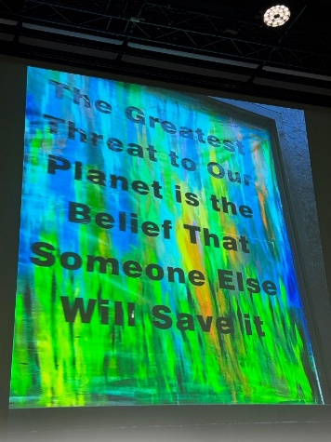
Representatives in European and Global Institutions
IFSW Europe has representatives in 10 European institutions and in the four IFSW global commissions. We meet four or five times a year online and share experiences, successes and challenges of speaking out for social work and influencing policy in contexts such as the European Union the Council of Europe, the UN in Geneva and and multilateral NGOs.
If you or someone in your association might be interested in acting as a representative for IFSW in European institutions or in an IFSW global commission, get in touch to find out more. In advance of the Delegates Meeting this year we will hold a webinar to share the work of representatives and explain how more people might get involved.

Strengthening Social Work Across Europe (SSWAE)
Our IFSW Global project continues to develop We are reaching out to associations in Europe that are not yet members of IFSW and/or of the Region. If you are involved with an association that would like to join IFSW Europe, do get in touch by email.
We also have a steering group working on new approaches to support particularly for social workers in Europe in hostile political, and policy and where working conditions are particularly hard.
We will report on this further at the May 6 Online Members meeting and the Delegates’ Meeting.
We will be presenting SSWAE in collaboration with partners from other regions at the Global Conference in Nairobi in June.
Funded Projects
We have been part of two funded projects – the Responsive Social Services project and the Co-Construction in the field of social welfare (COCOSO) project.
Responsive is concluding and we held a webinar on 11th March to explore the implications of this extensive research for social workers in practice and in training. Summary documents and presentations from the webinar will be uploaded to the website. Read more here https://responsive-europe.eu/
Cocoso is continuing and IFSW Europe has a small but significant role in training and supporting participants in developing their understanding of co-participative change-making and influencing in social welfare and justice https://cocoso.parisnanterre.fr/

New project themes for 2026
Based on feedback from our members discussions in recent Delegates’ Meetings, the Executive is working on proposals for two new projects to present to the Delegates Meeting in October, These are both major topics preoccupying members at national level, impacting social work and crucial considerations for IFSW E as we work to strengthen and support the profession to be fit for the next decades,

- AI and digital technologies: We will be holding an initial webinar on this theme in June to explore current practices, concerns and impact – more details to follow

- Working conditions and wellbeing for social workers: The Executive is working with members to produce a proposal for a project at the Delegates’ Meeting in Utrecht in October 2026. We welcome inputs and ideas on how we take this forward.
If you would like to feed in your ideas on these topics and get involved, please get in touch via europe@ifsw.org

IFSW Global
The next big global events are
The Global General Meeting (GM) on 23/24 June will be held in Nairobi and hybrid (online) https://www.ifsw.org/general-meeting-2026/

Global conference 26-29 June. You still have time to book for the conference online until the end of May. https://swsd2026.or.ke/



European Conference Athens, Greece 2027!
A quick update on plans for the European Regional Conference in Athens, Greece in the Autumn of 2027.

The European Executive team met with colleagues in Athens at the end of March, and together we agreed on the broad theme of the conference, the shortlist of venues and date options. We expect to have details and initial advertising available within the next few months. We will keep you all informed. Any questions or suggestions for Athens, please contact europe@IFSW.org

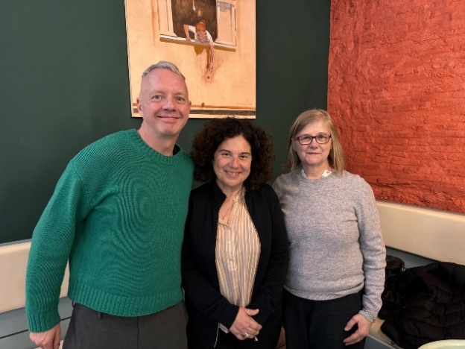

(L to R) Andreas Kikvik, IFSW E Vice President; Triantafyllia ('Fyllio') Athanasiou Hellenic Association President and Ruth Allen, IFSW E President together in Athens.

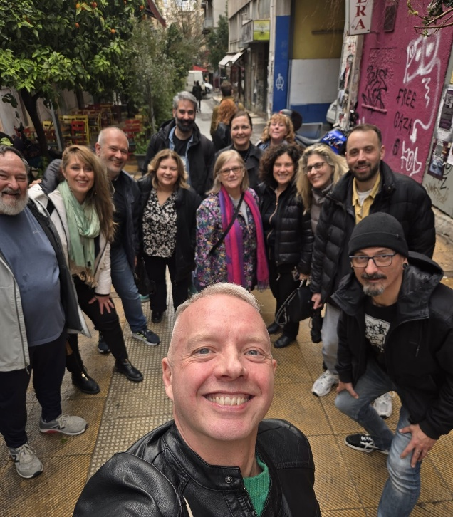

The Hellenic Association and IFSW Europe Executive Super Team!

New Social Workers Network (NSWN)
Please remember the ongoing open invitation for member associations to connect your new and young social workers and students with the growing NSWN community. Email here for more information.
newsocialworkers@ifsw.org
……………………………………………….

