الــجــمـــــعـــيـة المـغـربـيـة
للمساعدين الاجتماعيين
Moroccan Association
of Social Workers

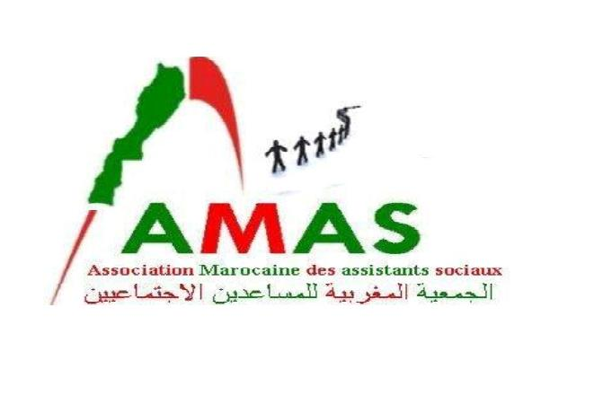

Fez on Wednesday 5 February 2014
Report about the training course

In the context of raising the capacity of practitioners in the field of social service geared for people with special needs. Moroccan Association of Social Workers organized a training course for the practitioners in the field of social work and number of members of associations in the region of Fes-Moulay Yacoub. The training course was on Monday 3 February 2014 in the multi-disciplinary center for women in difficult situations which existed in rural community called “Alwadayn community” the session was in coordination with the Delegation of National Cooperation in the region of Fes-Moulay Yacoub and in partnership of the rural women’s association for development and culture “tender women” as well as the general union of sociologists social works and psychologists from Yemen. The overall objective of this session was to: develop the skills of practitioners in the field of social work intended for people with special needs to develop the efforts of social workers and actors from associations and governmental and non- governmental organizations in the field of targeted programs for people with special needs.
The training supervised by:
- the professor of social work Mr .Hamoud Hassan Talaat Secretary -General of the General Union for social workers and psychologists (yemen )
- Mr. Mohammed Elardi the president of the Moroccan Association for social workers and coach in the techniques of listening , listening and social mediation
- Professor Sadiq Rajawi President of the Association for the Rehabilitation of the Blind of Yemen
During the official opening of the session Mr. delegate national cooperation praised the importance of these initiatives that contribute to the strengthening of coordination and cooperation among all stakeholders to improve the conditions of static province of Moulay Yacoub and raise the capacity of stakeholders in the management of social welfare institutions , besides noted Mr. Chairman congregation village of “Allwadayn” embrace of the center of this session noted the efforts of the members of the Moroccan Association of social workers .
In his speech, the President of the Moroccan Association of social workers on the quality of the organization and the reception of the session by Mr. delegate national cooperation province of Moulay Yacoub and the support of the public authorities and the elected representative of the President of the Allwadayn community for his support for this initiative, which contribute to the rehabilitation of community institutions to participate in the desired development in the region .
After the end of the training course we distributed certificates to all participates.

Moroccan Association of Social Workers
Adress : av saint louiss hay saaada –N 34 app 3
Telephone : 00212 673 62 22 77 E-mail :elardi74@yahoo.fr

